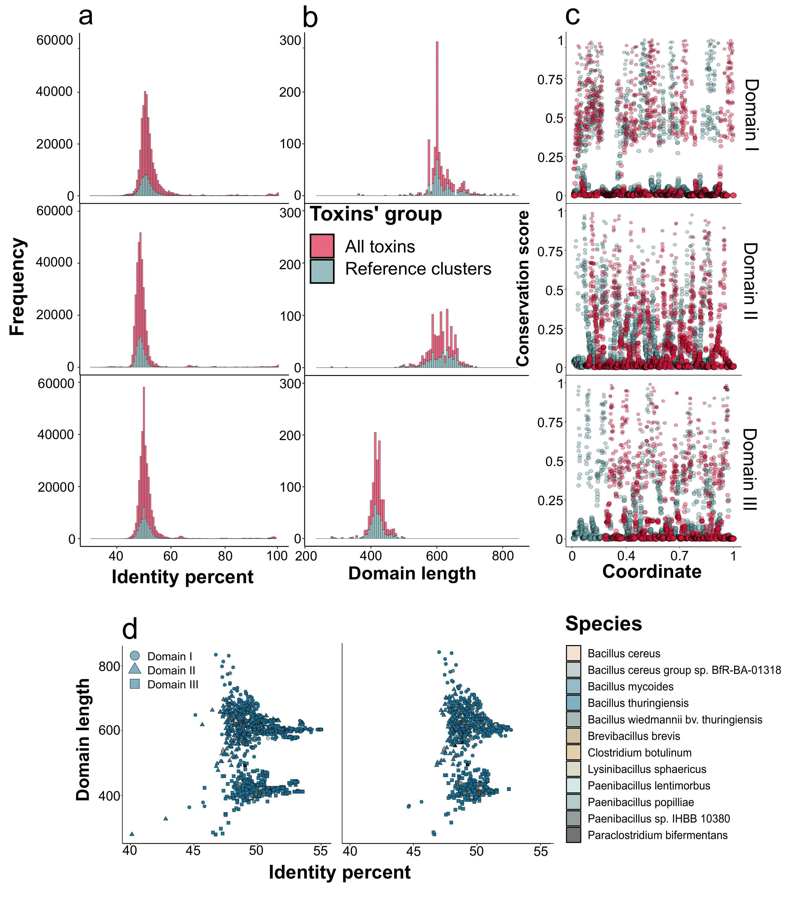

**Fig. S1**. Properties of Cry toxin sequences identified in four publically available datasets, namely, NCBI Assembly (1), Genebank, IPG (identical protein groups), and the BPPRC (Bacterial Pesticidal Protein Resource Center) (2). (**a**) The total frequency of domain-wise similarity between all Cry toxins’ sequences used in the study. The color code depicts the type of the dataset, namely, all toxins and reference clusters obtained using CD-HIT with a 95% identity threshold. (**b**) Distribution of the domains’ lengths in the analyzed dataset. (**c**) Per-site conservation scores in the sequences of the domains calculated as the maximum frequency of non-gap symbols in the alignment of the particular domain. The first domain has a higher conservation score with a mean of 0.23 in comparison with the second and third domains (0.16). The number of highly conserved sites with conservation scores exceeding 0.85 reached 16, and 41 conserved sites for the first domain, the second, and the third domains, respectively. (**d**) The dependence between the length of the domain and mean pair-wise identity for the respective toxin with all toxins from the dataset. The color corresponds to the species’ attributions, while the shape encodes the domain type.

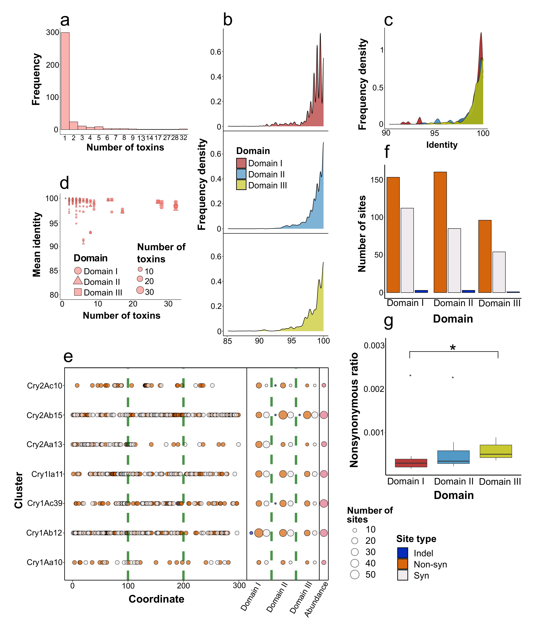

**Fig. S2**. Characteristics of cd-hit clusters of Cry toxins obtained using a 95% identity threshold. (**a**) Frequency of clusters according to the number of toxins within them. (**b**) Mean pairwise similarity of the domains’ sequences within all cd-hit clusters obtained using a 95% identity threshold. (**c**) The same distribution of domain-wise identities in clusters containing more than 10 toxins. (**d**) Dependence between the abundance of the cluster and mean domain-wise identity between toxins within the cluster. The shape of points denotes the domain, while the size encodes the number of toxins. (**e**) The distribution of pairwise identities of the domains within clusters encompassing more than 10 toxins. Codon-wise mismatches between the sequences of the domains within clusters with more than 10 toxins. The left panel shows the coordinates of mismatches colored according to their type (synonymous, non-synonymous, and indels) with a green dashed line designating the boundaries between the domains. The middle panel summarizes the number of such mismatches per cluster, while the right panel denotes the abundance of the cluster. (**f**) The total number of substitutions identified in the particular domain. (**g**) The normalized non-synonymous ratio for the particular domain calculated as the sum of non-synonymous substitutions and indels divided by the number of synonymous mismatches multiplied by the length of the cluster-wise domain-based alignment and the number of toxins within the cluster. Asterisks denote statistical significance using the Wilcox test when comparing the respective values of domains’ sequences.

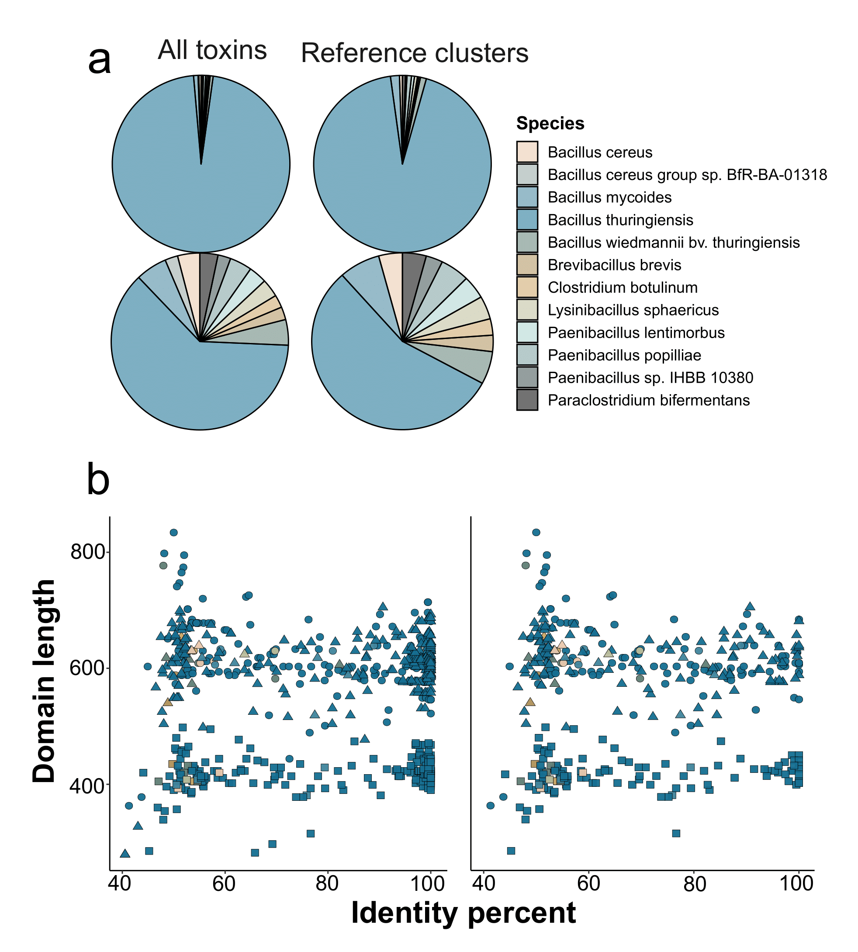

**Fig. S3**. Properties of Cry sequences of the analyzed dataset with respect to species in which toxins were identified and the identity with the respective known homologs. (**a**) Distribution of species’ attributions of 3D-Cry toxins dataset. Shown are the data for all toxins and reference clusters obtained using cd-hit with a 95% identity threshold. Upper plots display the absolute numbers, while the lower plots depict square root-adjusted values for better details. A total of 30 toxins were attributed to other species, including *Bacillus mycoides*, *B. cereus*, *B. wiedmannii*, etc., or pertained to different genera, such as *Paraclostridium bifermentans* and *Clostridium botulinum*. (**b**) The relationship between the length of the domains and the identity with the respective homolog from the *Bt* nomenclature for all toxins and only novel ones. The color corresponds to the species’ attributions, while the shape encodes the domain type.

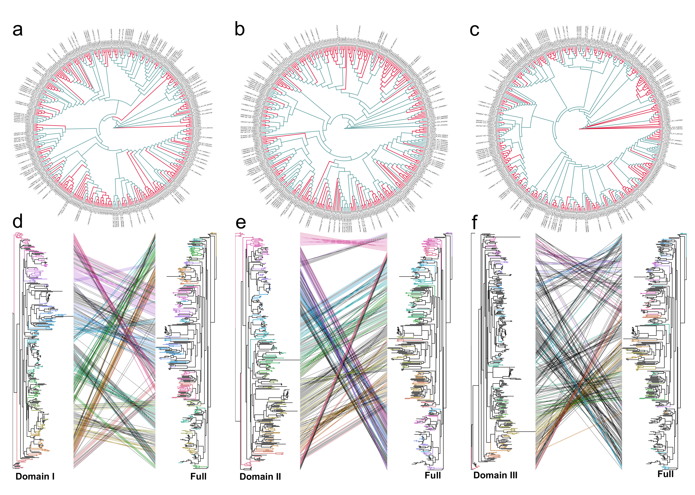

**Fig. S4**. Phylogenetic inferences based on the sequences of the domains in the analyzed dataset. The upper figures show reconstructed ML trees (maximum likelihood) obtained from the alignments of the first (**a**), second (**b**), and third (**c**) domains. Color code denotes the type of toxins with the red color corresponding to known toxins deposited in the *Bt* nomenclature and the blue color designating novel proteins. The lower figures depict tanglegrams demonstrating topological differences of reference ML phylogeny based on the concatenated alignments of the domains with partitioned evolutionary models with the respective trees of the first (**d**), second (**e**), and third domains (**f**). The optimal evolutionary model for the third domain differed from the other two domains (HKY+G4 vs. TVM+G4).

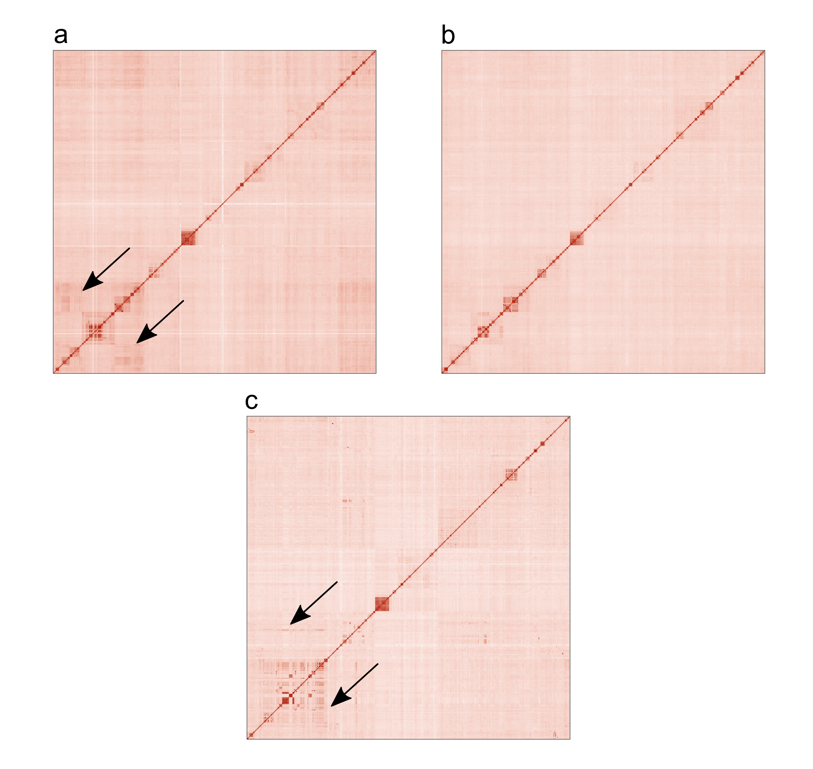

**Fig. S5**. Heatmap with the pair-wise identity of sequences of the first (**a**), second (**b**), and third (**c**) domains. The order of rows and columns corresponds to the order in the reference ML phylogeny based on the concatenated alignments of the domains with a partitioned evolutionary model. Arrows indicate the zones in which local identity differs from the expected order.

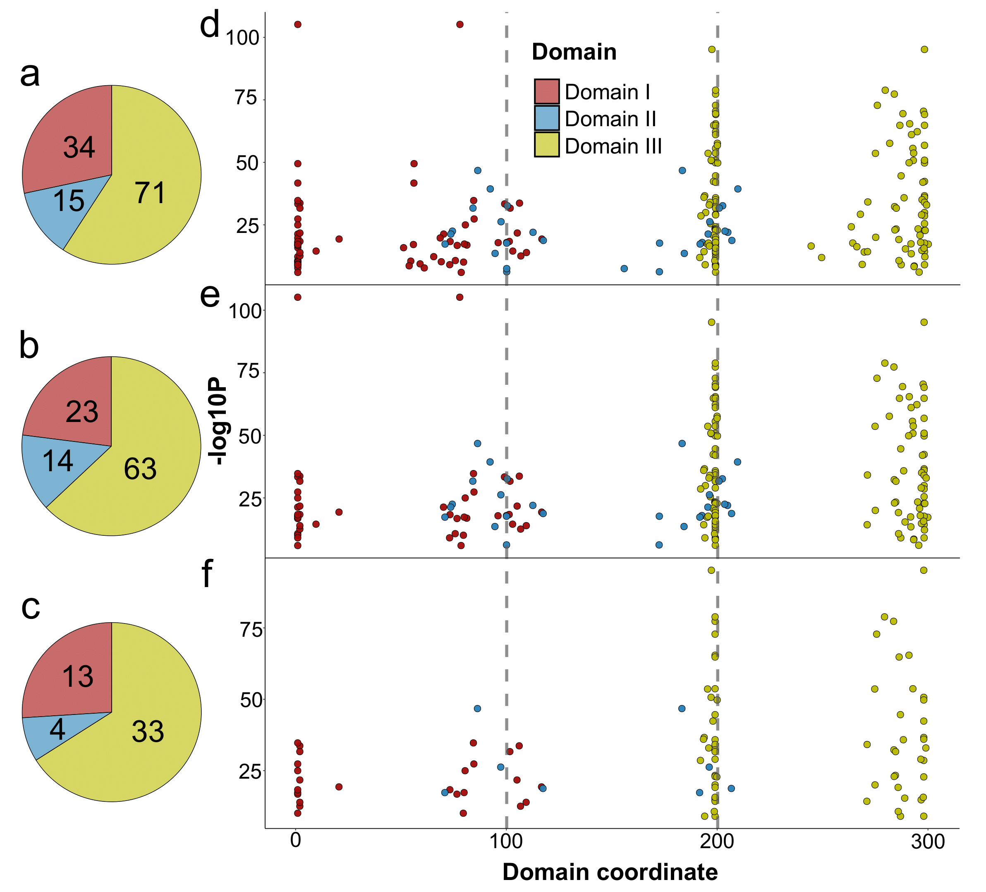

**Fig. S6**. Recombination events reported by RDP4 launched on MAFFT-aligned nucleotide sequences of 3-D Cry toxins. (**a**) The total number of raw events identified with RDP4. (**b**) The number of events after discarding partial exchanges, i.e., affecting less than 70% of the domains’ lengths (**c**) Types of events in the final dataset with filtering based on tree congruence. The color corresponds to the transferred domain. (**d**) Distribution of breakpoint coordinates for recombination events, as well as, those devoid of partial exchanges (**e**), and filtered on the basis of tree congruence (**f**). On the x-axis, the relative coordinate in the sequence is presented. Plotted on the y-axis, is the mean p-value from all recombination detection tests included in the RPD4 software. Grey dotted lines represent the boundaries of the domains. For a detailed description of the filtration process, see Fig. S34a.

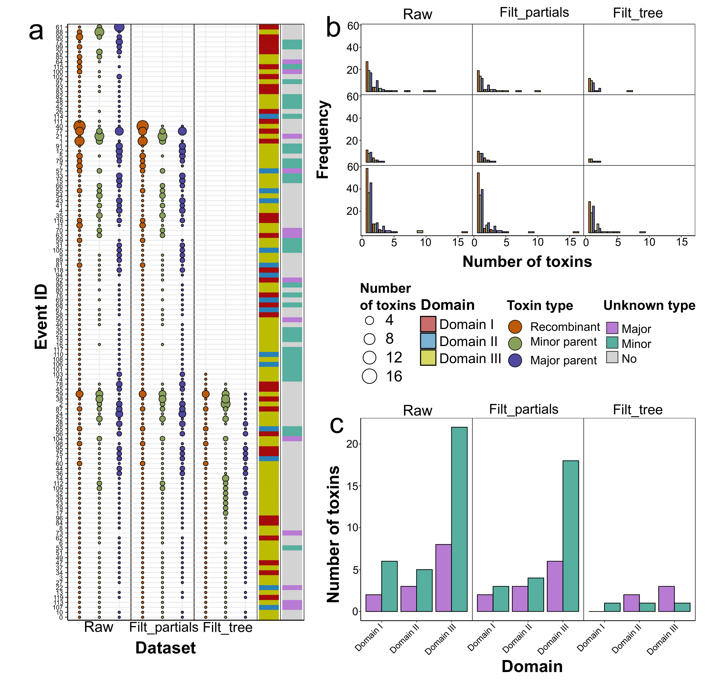

**Fig. S7**. Properties of recombination events detected with RDP4 launched on MAFFT-aligned nucleotide sequences of 3-D Cry toxins. Tree datasets are considered: “*Raw*” index encodes all events detected by RDP4, “*Filt_partials*” denotes the set of events affecting more than 70% of the respective domain, whereas “*Filt_tree*” marks the final dataset with filtering on the basis of tree congruence. For a detailed description of the filtration process, see Fig. S34a. (**a**) Event-wise characteristic of recombination exchanges within three datasets. Each point represents the set of toxins colored according to their type in the event. i.e., recombinants, and parents. Parents are marked as major or minor with the latter providing two domains, and the former transferring one domain. The size of the point is proportional to the number of toxins. The first adjacent line encodes the type of the event (the transferred domain), while the second line provides information about whether the parent is unknown, i.e., absent in the analyzed dataset. (**b**) Distribution of the number of toxins within the events. The color of the bar represents the type of recombination participants. Plotted on the x-axis is the number of toxins, while the y-axis denotes the number of events. In the final dataset, 45 events included one recombinant per event, while 4 events encompassed two toxins, and 1 event comprised 5 participants. The same goes for parents. Of all events, 31 were those with a single minor and major parent, 13 possessed either two or one major or minor parent (with 3 parents in total), and the rest of the events (6) were related to a greater number of parents. (**c**) The number of unknown parents within the recombination events. The total number of events grouped according to the transferred domain is presented. Color encodes the type of the parent (minor/major). The reduction in the number of events with unknown parents was from 46 (38%) to 8 (16%). In the final set, 5 major and 3 minor unknown parents remained.

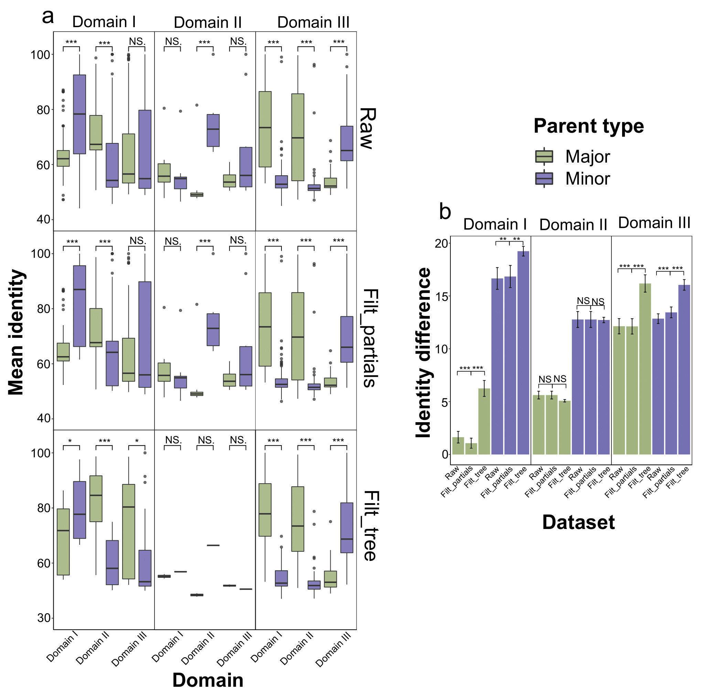

**Fig. S8**. Distribution of mean sequence identity and mismatch rates of recombination events detected with RDP4 launched on MAFFT-aligned nucleotide sequences of 3-D Cry toxins. Tree datasets are considered: “*Raw*” index encodes all events detected by RDP4, “*Filt_partials*” denotes the set of events affecting more than 70% of the respective domain, whereas “*Filt_tree*” marks the final dataset with filtering on the basis of tree congruence. For a detailed description of the filtration process, see Fig. S34a. All the measurements refer to three groups of recombination events according to the swapped domain. (**a**) Average domain-wise nucleotide identity between the sequences of recombinants and parents. Asterisks denote statistical significance using the Wilcox test when comparing the respective values of major and minor parents. The mean similarity between the transferred domain of recombinants and minor parents reached 80%, 66%, and 71% for events in which the first, the second, and the third domains were swapped, respectively. (**b**) The dataset-wise mean identity difference between the transferred and non-transferred domains of major and minor parents compared with the domain sequences of recombinant toxins. Asterisks denote statistical significance using the Wilcox test when comparing three sets of recombination events. Error bars represent mean square error. Difference estimates reached 19%, 12%, and 16% when considering minor parents, and 6%, 5%, and 16% concerning majors for events with the first, second, and third domains, respectively.

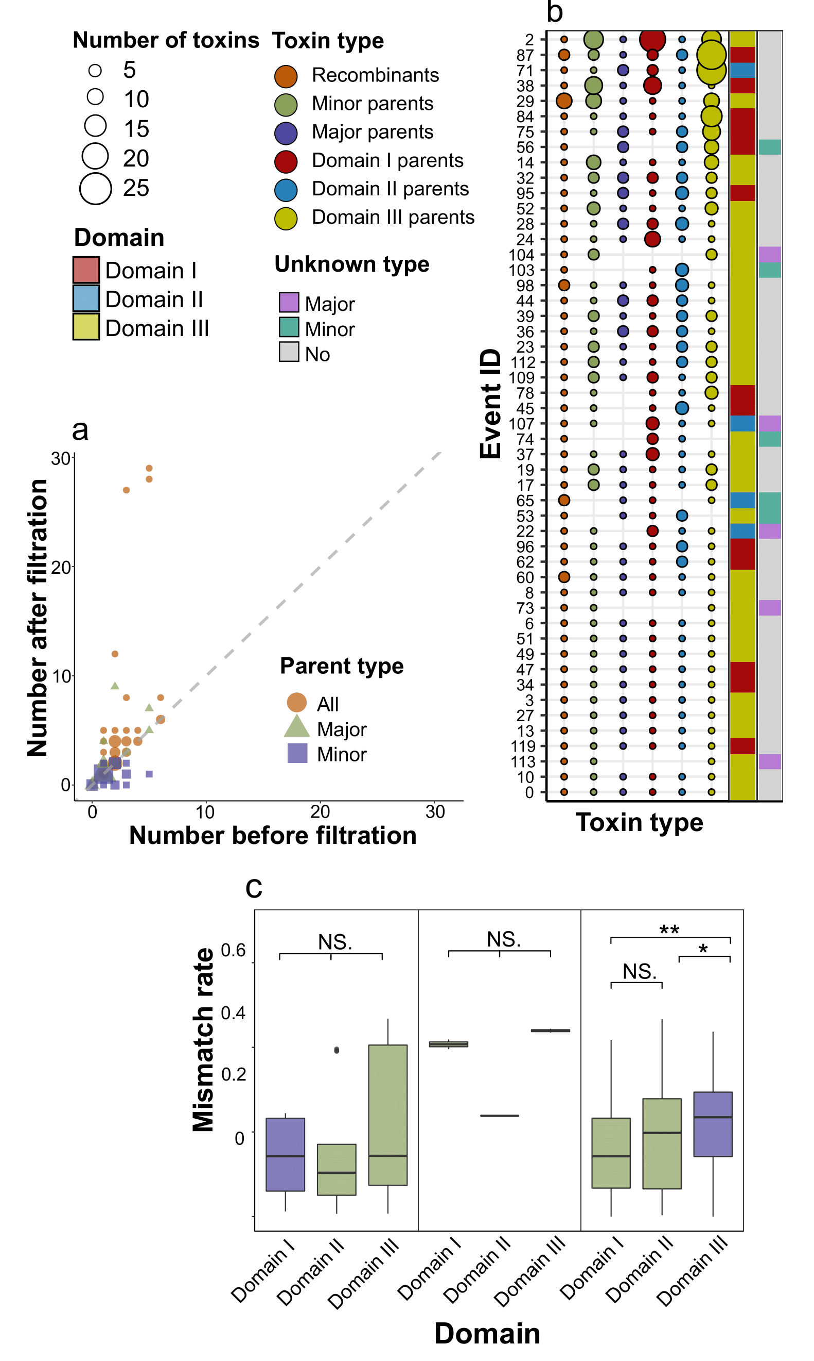

**Fig. S9**. Properties of the final dataset of recombination events detected with RDP4 launched on MAFFT-aligned nucleotide sequences of 3-D Cry toxins. For a detailed description of the filtration process, see Fig. S34a. (**a**) Event-wise characteristic of recombination exchanges. Each point represents the set of toxins colored according to their type in the event. i.e., recombinants, and parents. Parents are marked as major or minor with the latter providing two domains, and the former transferring one domain. Parents identified when considering domain-wise trees for each individual domain are also shown. The size of the point is proportional to the number of toxins. The first adjacent line encodes the type of the event (the transferred domain), while the second line provides information about whether the parent is unknown, i.e., absent in the analyzed dataset. (**b**) The effect of tree-wise filtration on the number of parents within recombination events. Plotted on the x-axis is the number of toxins reported by RDP, while the y-axis represents the number of parents after filtration. The shape and the color of points correspond to the type of parents. A total of 35 events remained unchanged, while for 8 events the number of majors increased, and for 7 events the number of minors was reduced. (**c**). Domain-wise number of mismatches between parents and recombinants normalized by the corresponding alignment. Mismatches were calculated only for transferred domains within the final filtered set of events. Asterisks denote statistical significance using the Wilcox test between domain-wise mismatch rates.

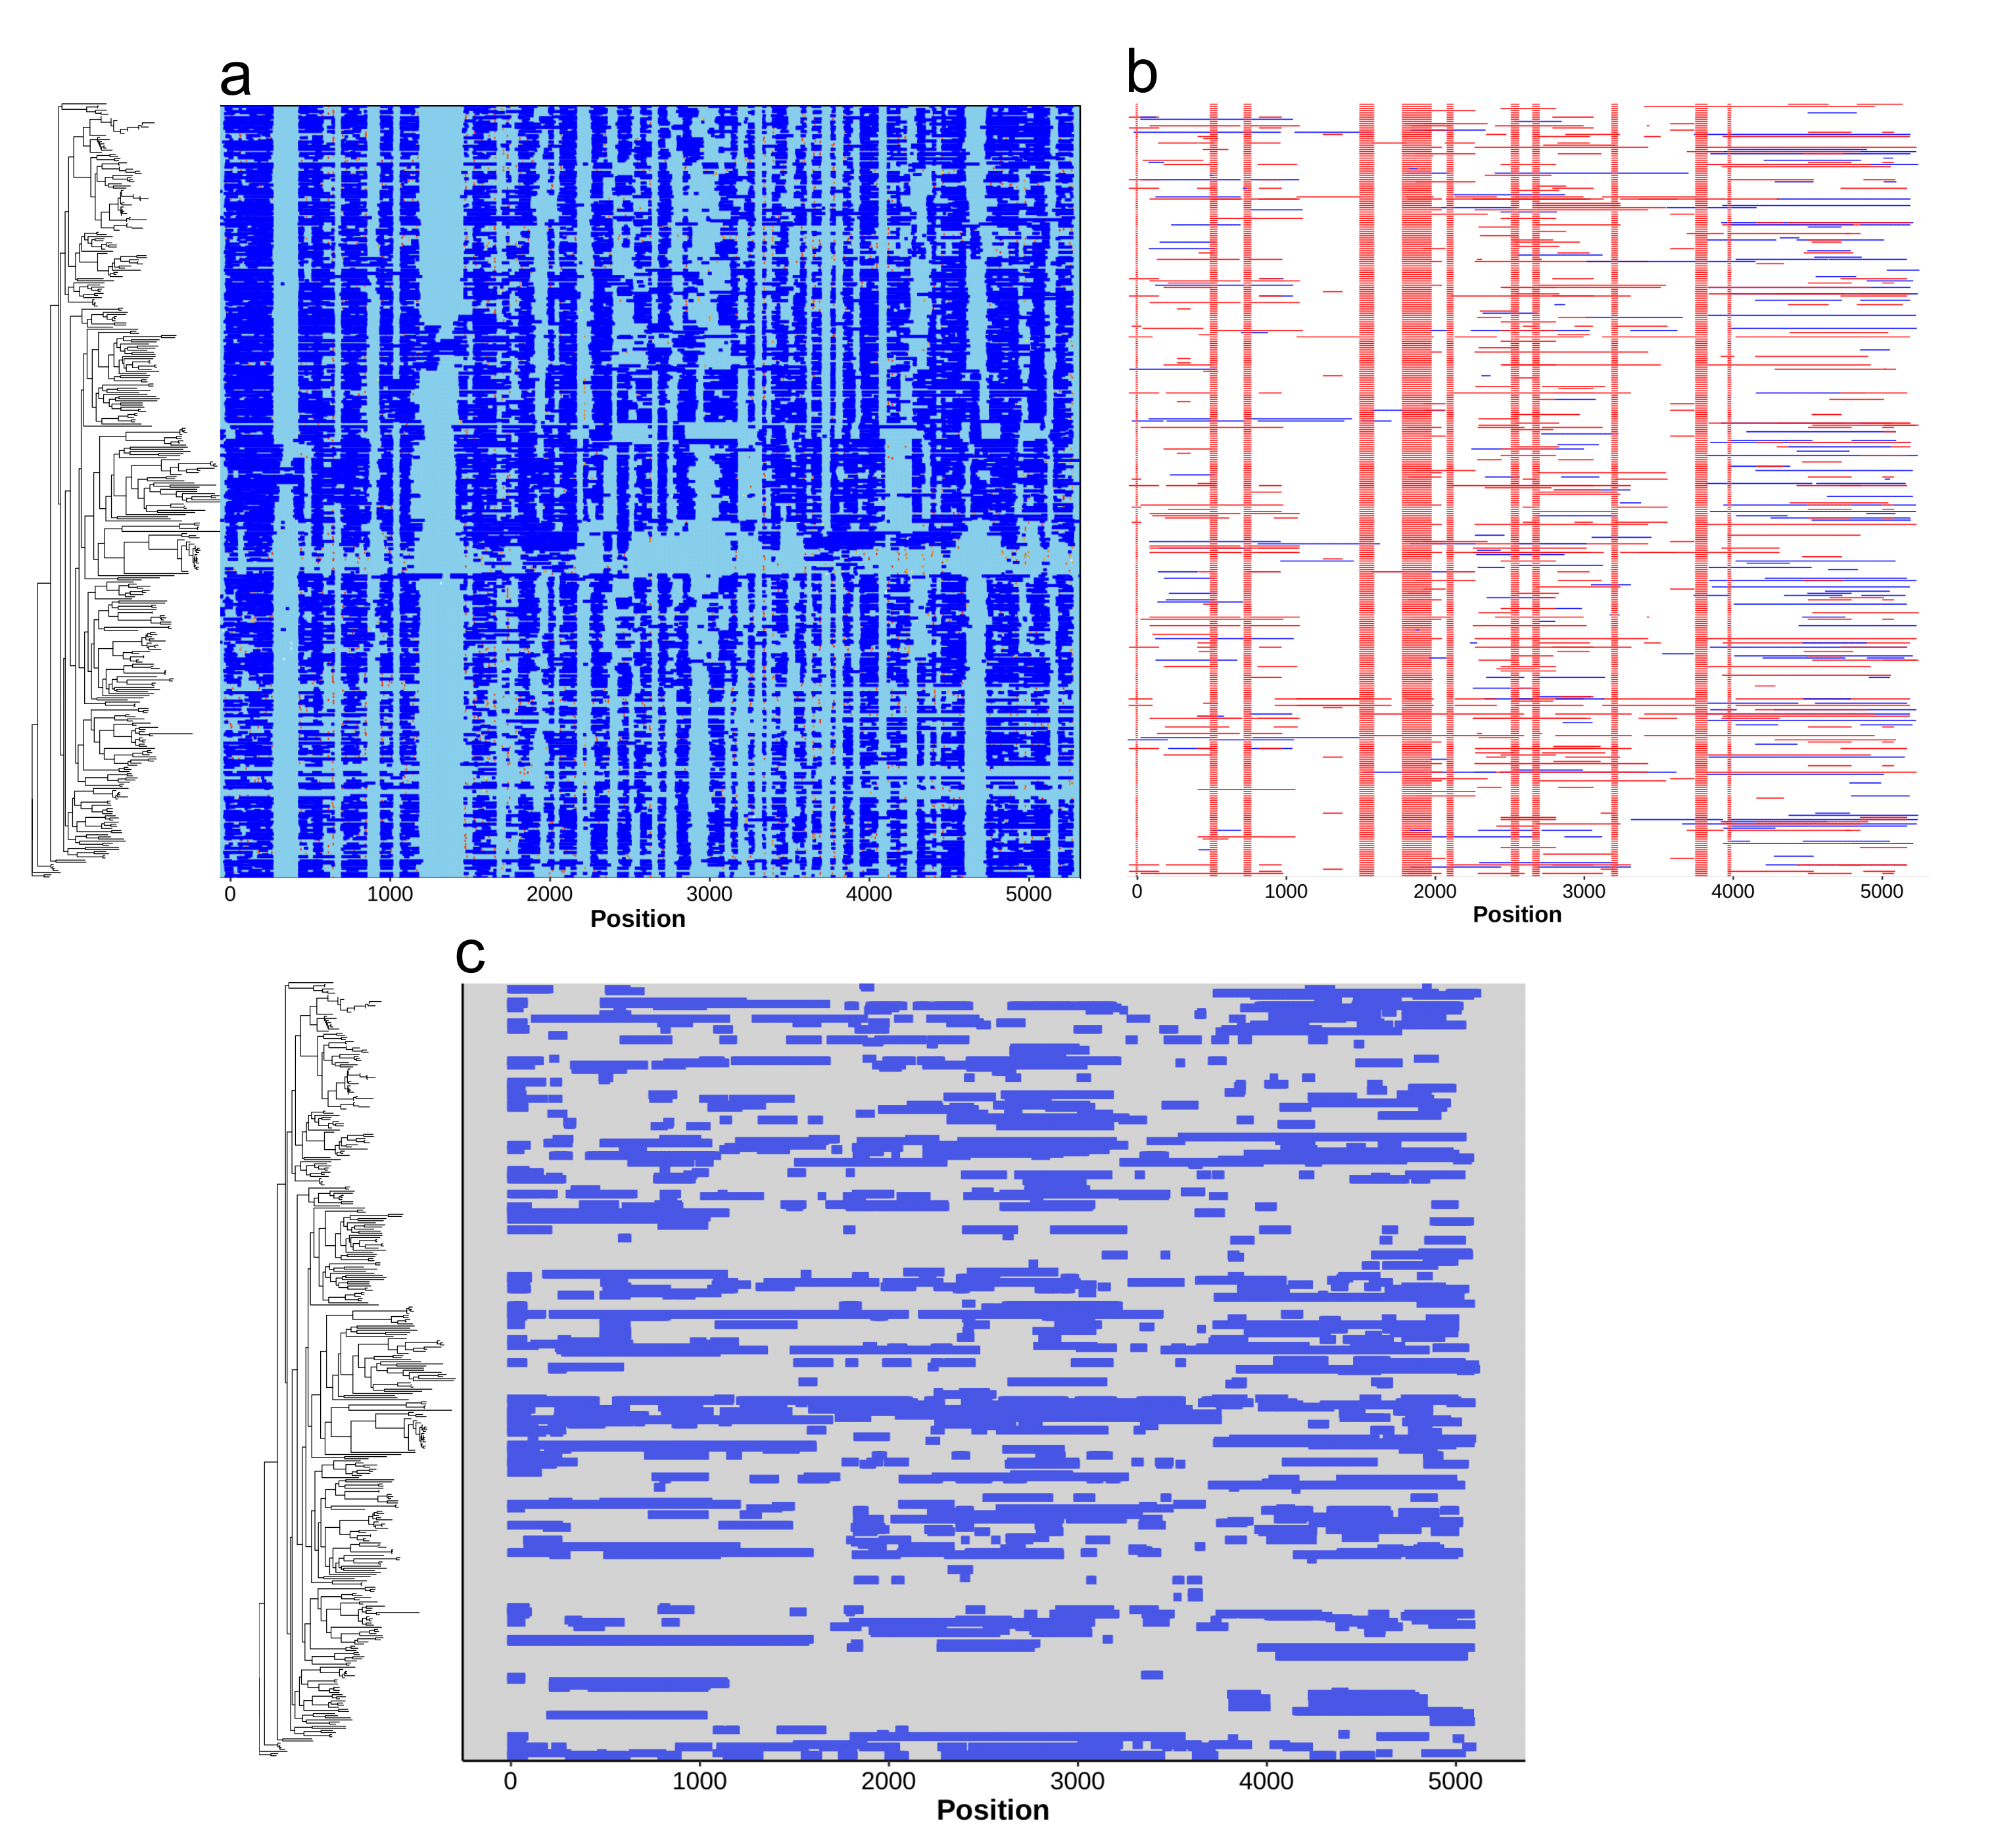

**Fig. S10**. Distribution of regions affected by recombination using ClonalFrameML (**a**), Gubbings (**b**), and fastGEAR (**c**). The order of rows corresponds to the reference phylogeny, and the positions refer to the MAFFT-generated alignment of processed toxins (regions from the beginning of the first and the end of the third domain). Putative exchanged areas are marked with blue and red colors.

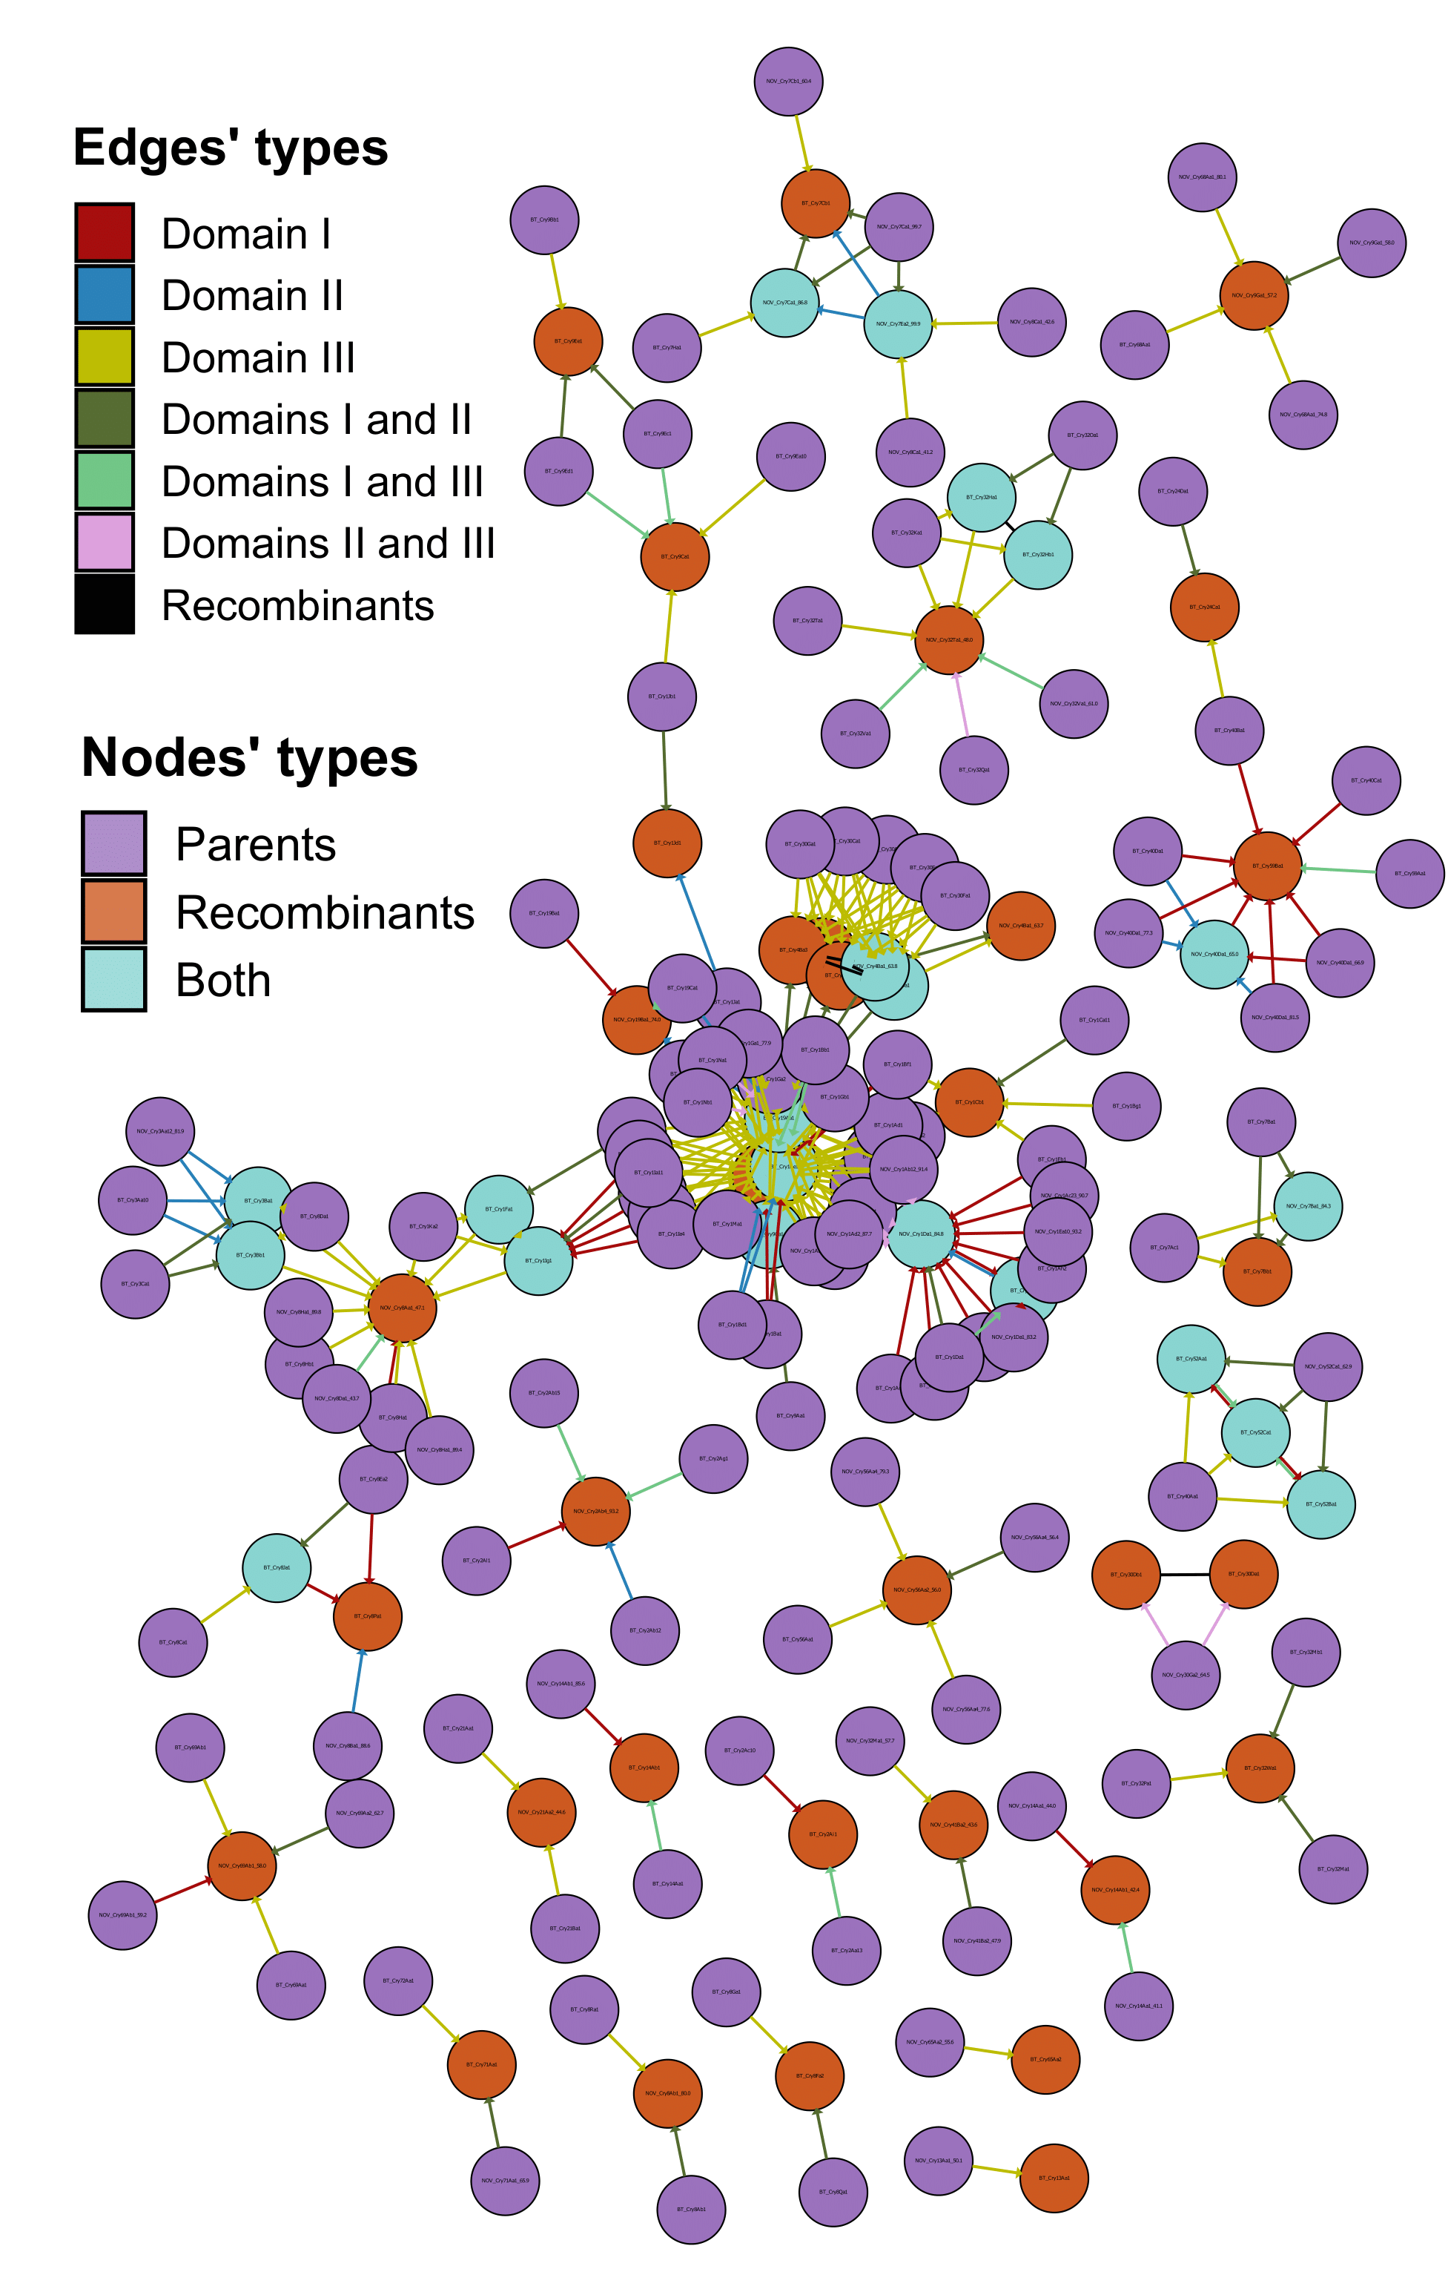

**Fig. S11**. The graph of domain exchanges between 3-D Cry toxins. The color of the node corresponds to the role of the toxin in recombination events, i.e., recombinants, parents, and those participating in multiple swaps thus being parents and recombinants simultaneously. Edges’ colors denote the domain transferred, namely, one domain for minor parents and two domains for major parents, respectively. Black edges connect toxins if a particular event contains multiple recombinants.

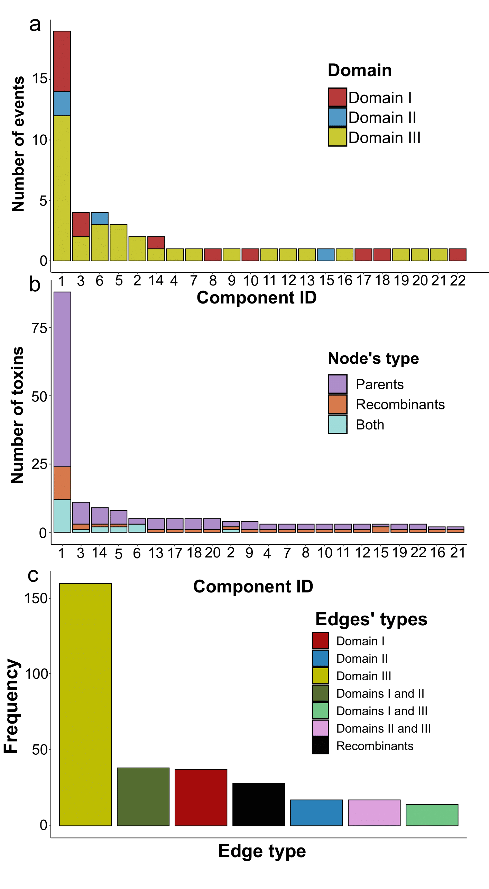

**Fig. S12**. Properties of weakly connected components of the recombination graph. (**a**) The number of recombination events within each connected component colorized according to the events’ types assigned with regard to transferred domains. (**b**) The number of toxins (nodes) within each connected component. The color corresponds to the role of the toxin in recombination events, i.e., recombinants, parents, and those participating in multiple swaps thus being parents and recombinants simultaneously. (**c**) The total number of graph edges within all connected components. Colors denote the domain transferred, namely, one domain for minor parents and two domains for major parents, respectively. Black edges connect toxins if a particular event contains multiple recombinants. In accordance with the distribution of events’ types, most of the edges refer to the third (161) and the first (41) domains as well as those presenting links from major parents amidst events involving the third domain with the first and the second domain transferred together (42).

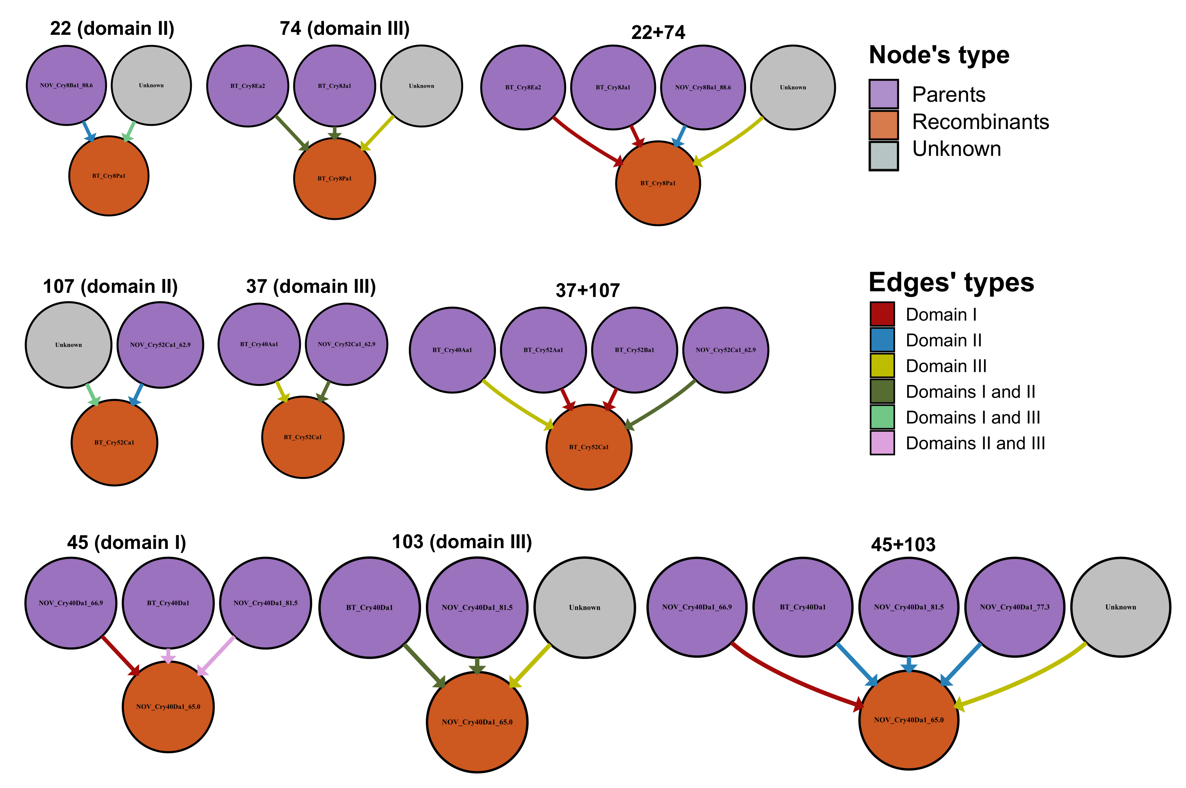

**Fig. S13**. Schemes of domain exchanges of linked recombination events, namely, those affecting the same recombinant. Shown are the initial parents reported by RDP4 and the corrected sets of parents for such events taken from the recombination graph. The color corresponds to the role of the toxin in recombination events, i.e., recombinants, parents, and unknown parents are shown as grey circles (unknowns are omitted in Fig. S11). The colors of the edges denote the domain transferred, namely, one domain for minor parents and two domains for major parents, respectively. In total, there were 3 pairs of events affecting 3 toxins: Cry8Pa1, Cry52Ca1, and Cry40Da1_65.0_CAH33957.1 with the latter demonstrating 65% similarity with the closest reference from the BPPRC (Bacterial Pesticidal Protein Resource Center) database (see tab. S23).

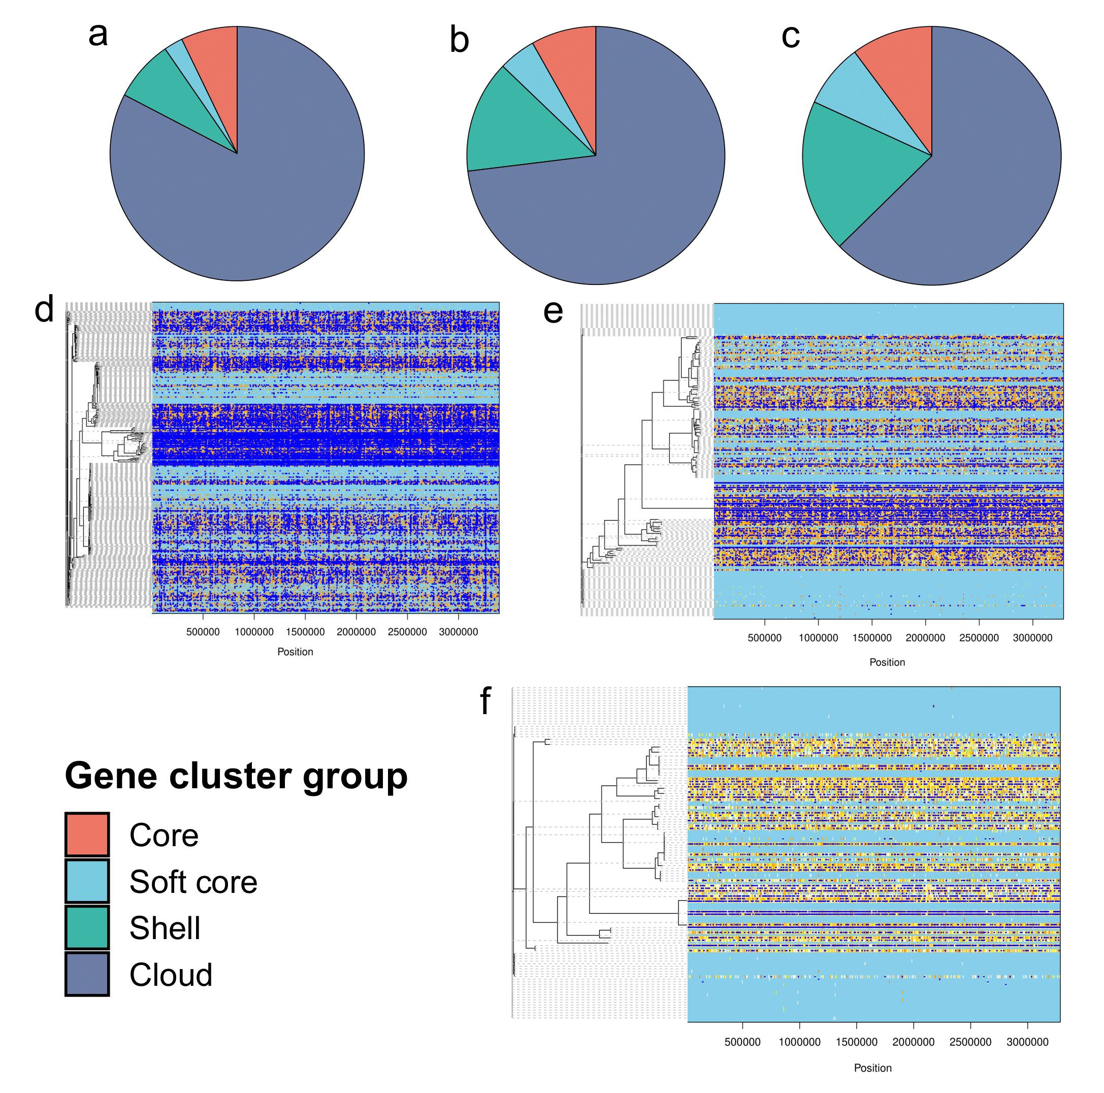

**Fig. S14**. Genetic diversity and recombination intensity if *Bt* assemblies bearing Cry toxins or lacking them. (**a**) The number of gene groups (core, soft core, shell, and cloud) within pangenomes reconstructed using Panaroo in all publically available *Bt* assemblies, as well as those containing 3-d Cry toxins (**b**), and participants of recombination events (**c**). (**d**) Regions susceptible to homologous recombination among all *Bt* genomes analyzed, assemblies bearing 3-d Cry toxins (**e**), and those harboring recombinants and parents involved in the domain exchanges (**f**). Recombination events detected with ClonalFrameML are marked with blue color and placed among concatenated core gene alignments obtained by Panaroo. Adjacent phylogenetic trees represent ClonalFrameML-corrected guiding trees reconstructed with FastTree from the core gene alignments.

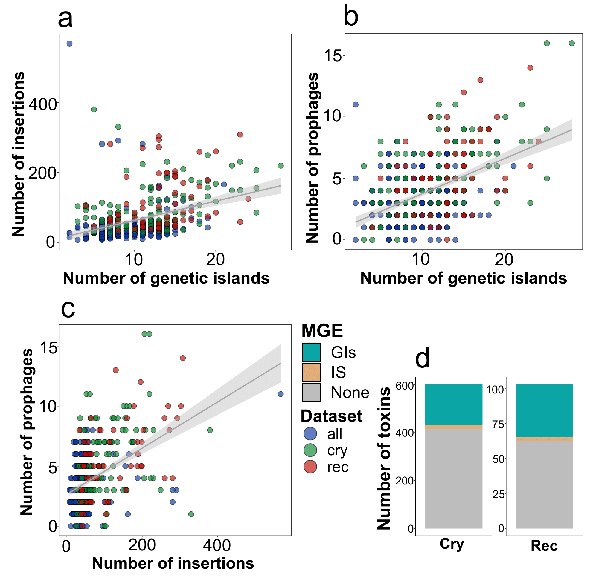

**Fig. S15**. The relation between mobile genetic elements (MGEs) and recombination events. The colors of points and box plots correspond to the sets of *Bt* assemblies, namely, all genomes (“*all*”), assemblies bearing Cry toxins (“*cry*”), and those incorporating participants in domain exchanges (“*rec*”). (**a**) Dependence between the total number of insertions (IS) and genetic islands (GIs), prophages and genetic islands (**b**), insertions and prophages (**c**) within the aforementioned sets of genomes. (**d**) The percentage of Cry toxins associated within the regions of IS and GIs. Shown are all 3-D Cry toxins and recombinants/parents involved in the domain exchanges.

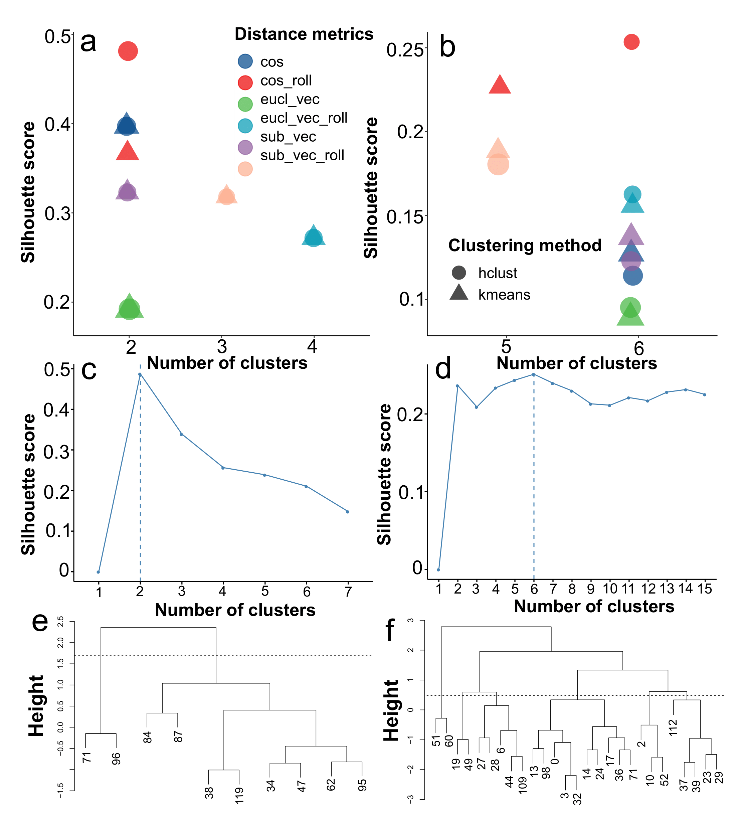

**Fig. S16**. Determination of optimal clusterization approach for event-wise groping of regions flanking breakpoints. The distance matrix used was based on integral estimates of per-coordinate identities between the sequences of major and minor parents within 100 b.p. regions surrounding the breakpoints. Three distance metrics were applied on the respective coordinate-wise estimated, namely Euclidean distance, Manhattan distance (the sum of the absolute distances), and cosine distance. The estimates are marked with prefixes ‘*eucl’*, ‘*sub’*, and ‘*cos’*, respectively. These methods were also used on the moving average of the identity values within the vectors to compare with a period of 7 b.p., which is delineated with the ‘*roll’* postfix. (**a**) Plotted is the most optimal number of clusters when using particular metrics according to the highest silhouette score calculated for the flanks located between the first and the second domain, and between the second and the third domains (**b**). The shape of the points encodes the clustering algorithm, namely, hierarchal clustering and k-means. Arrows indicate the best metric chosen for further analysis (**c**) The distribution of silhouette scores for a diverse number of clusters within the best method for the first and the second flanks (**d**). (**e**) Dendrogram visualizing hierarchal clustering patterns for the first and the second flanks (**f**). The numbers correspond to recombination events. The Grey dashed line indicates the threshold for clusters’ delineation.

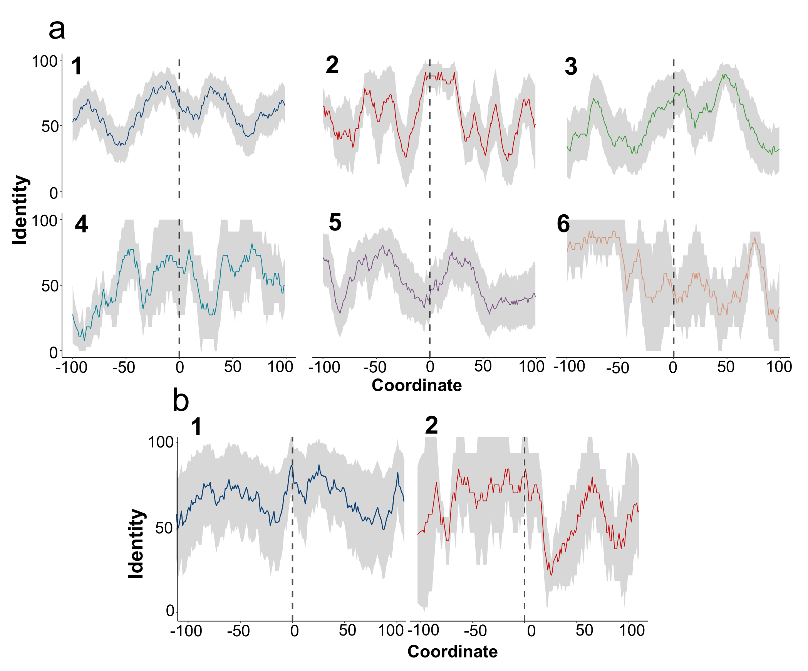

**Fig. S17**. Mean identity within regions surrounding recombination breakpoints. (**a**) Coordinate-wise mean identity between parental sequences in recombination events within two regions, namely between the second and the third domains and between the first and the second domains (**b**). Identity is calculated for 100 b.p. flanking regions before and after the respective breakpoints. Dashed lines indicate the location of breakpoints. Grey areas represent the standard error. The data is grouped according to the clusters of events obtained using the most optimal clustering pipeline and algorithm, namely hierarchical clustering based on the cosine distance metrics applied on the rolling average of the vectors with coordinate-wise identities.

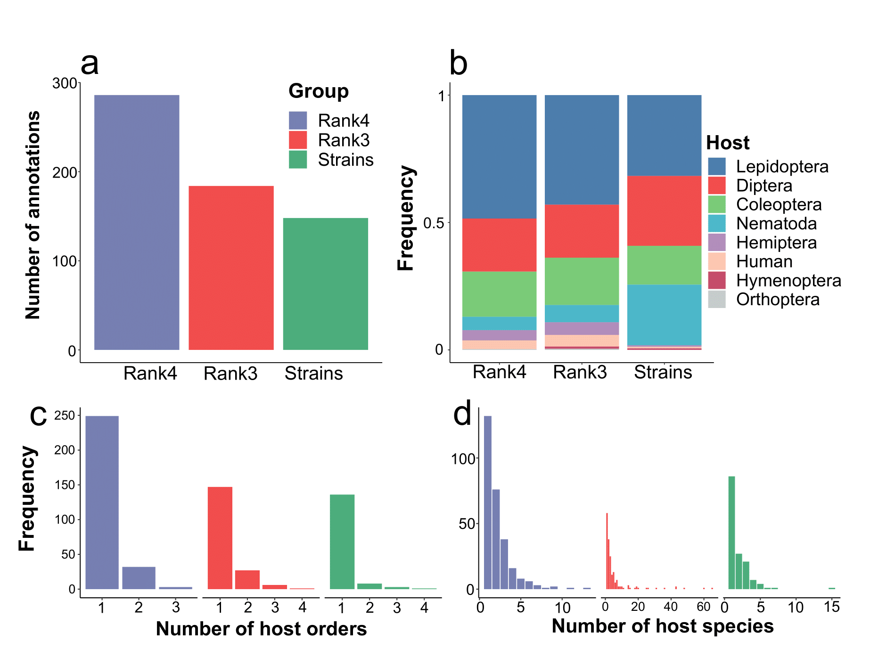

**Fig. S18**. Overall distribution of activities of studied Cry toxins and strains encompassing them. (**a**) The total number of instances having at least one known host to which the activity was shown. Three groups are considered, namely proteins within the fourth (100% identity) and the third rank (95% identity within the toxins’ group), and strains. (**b**) The proportion of individual bioassays made for toxins and strains. The colored within-bars fraction corresponds to the number of unique species attributed to higher taxonomical categories (**c**) The frequency of strains and proteins in the context of the amount of known affected host orders and species (**d**).

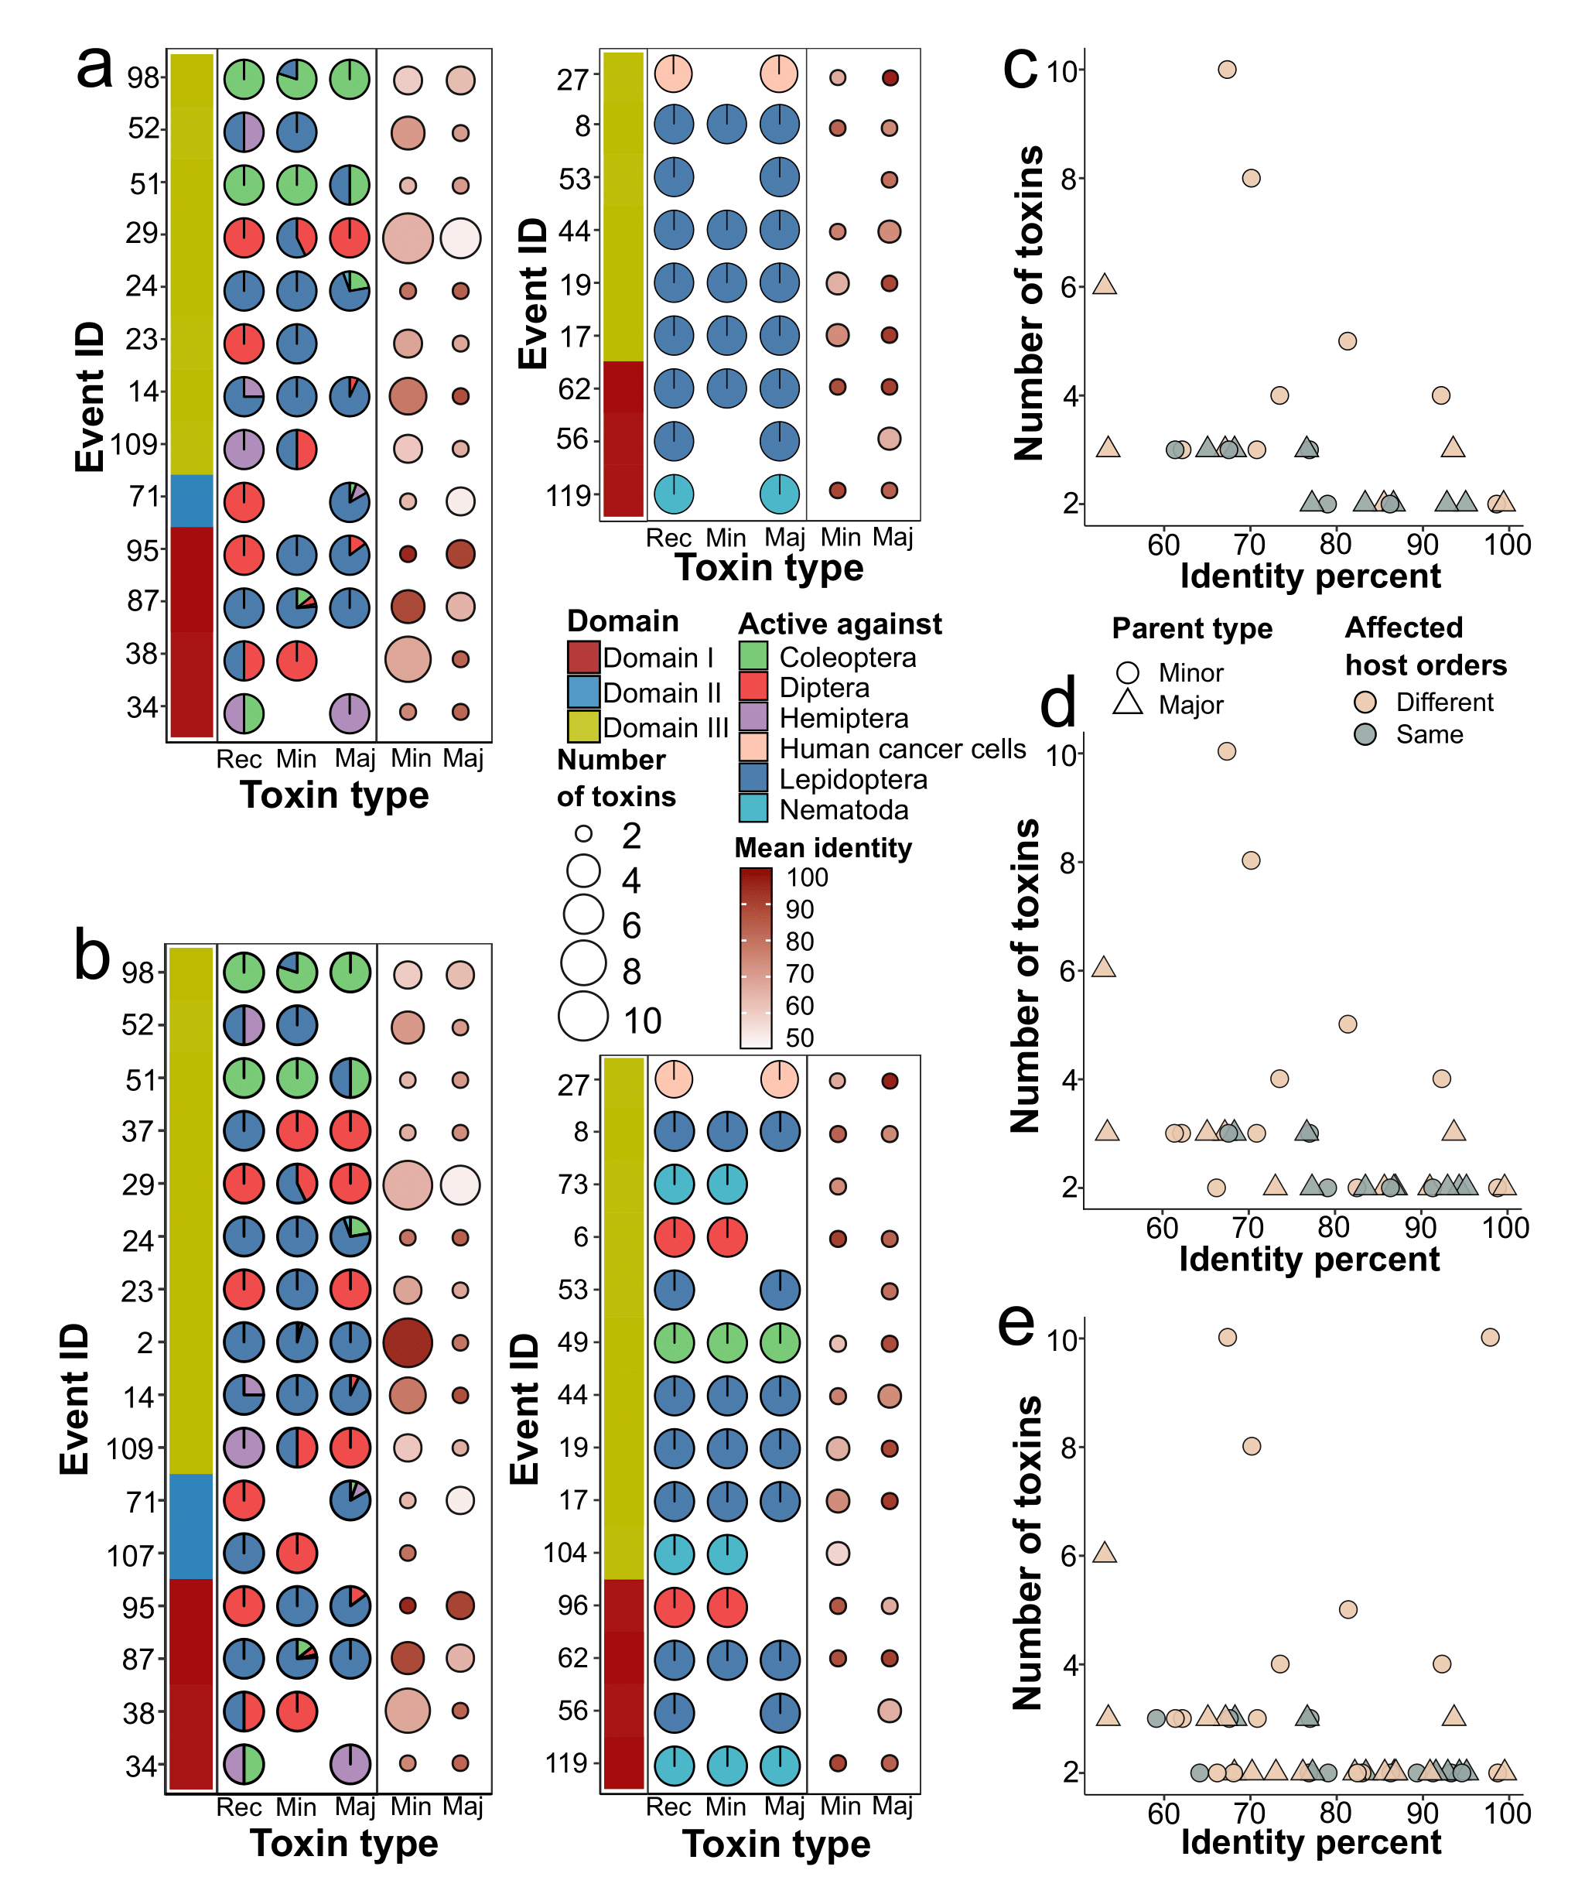

**Fig. S19**. The properties of parents and recombinants in terms of the hosts attributed to them. (**a**) The percentage of species attributed to different orders against which recombinants and parents are active. The data on the activity is based on the third rank of the toxins and strains if the respective protein-wise host spectrum is unknown (**b**). The portion of particular orders within the pie charts is color-coded. The events are split into two panels, namely those in which at least one toxin exhibits the activity to the order differing from other types of parent and/or child. The left adjacent bar corresponds to the domain transferred in the particular event. The right adjacent panel shows the number of toxins (recombinants and the parents, either major or minor ones). ‘*Rec*’ indicates recombinants, ‘*Min*’ – minor, and ‘*Maj*’ – major parents, respectively. The size of the dots is proportional to the number of participants, whereas the intensity of the color delineates the mean pair-wise identity between the transferred domains. (**c**) The dependence between the number of toxins and the mean identity of the transferred domain in the sets of events for which the associated hosts are available on the basis of third and fourth (**d**) ranks of the toxins and strains as well (**e**). The shape of the dots encodes the type of parent, and the color indicates whether the sets of host orders are the same or different. According to Wald's z-statistic of the logistic regression, changes in the infected orders are determined by the number of toxins.

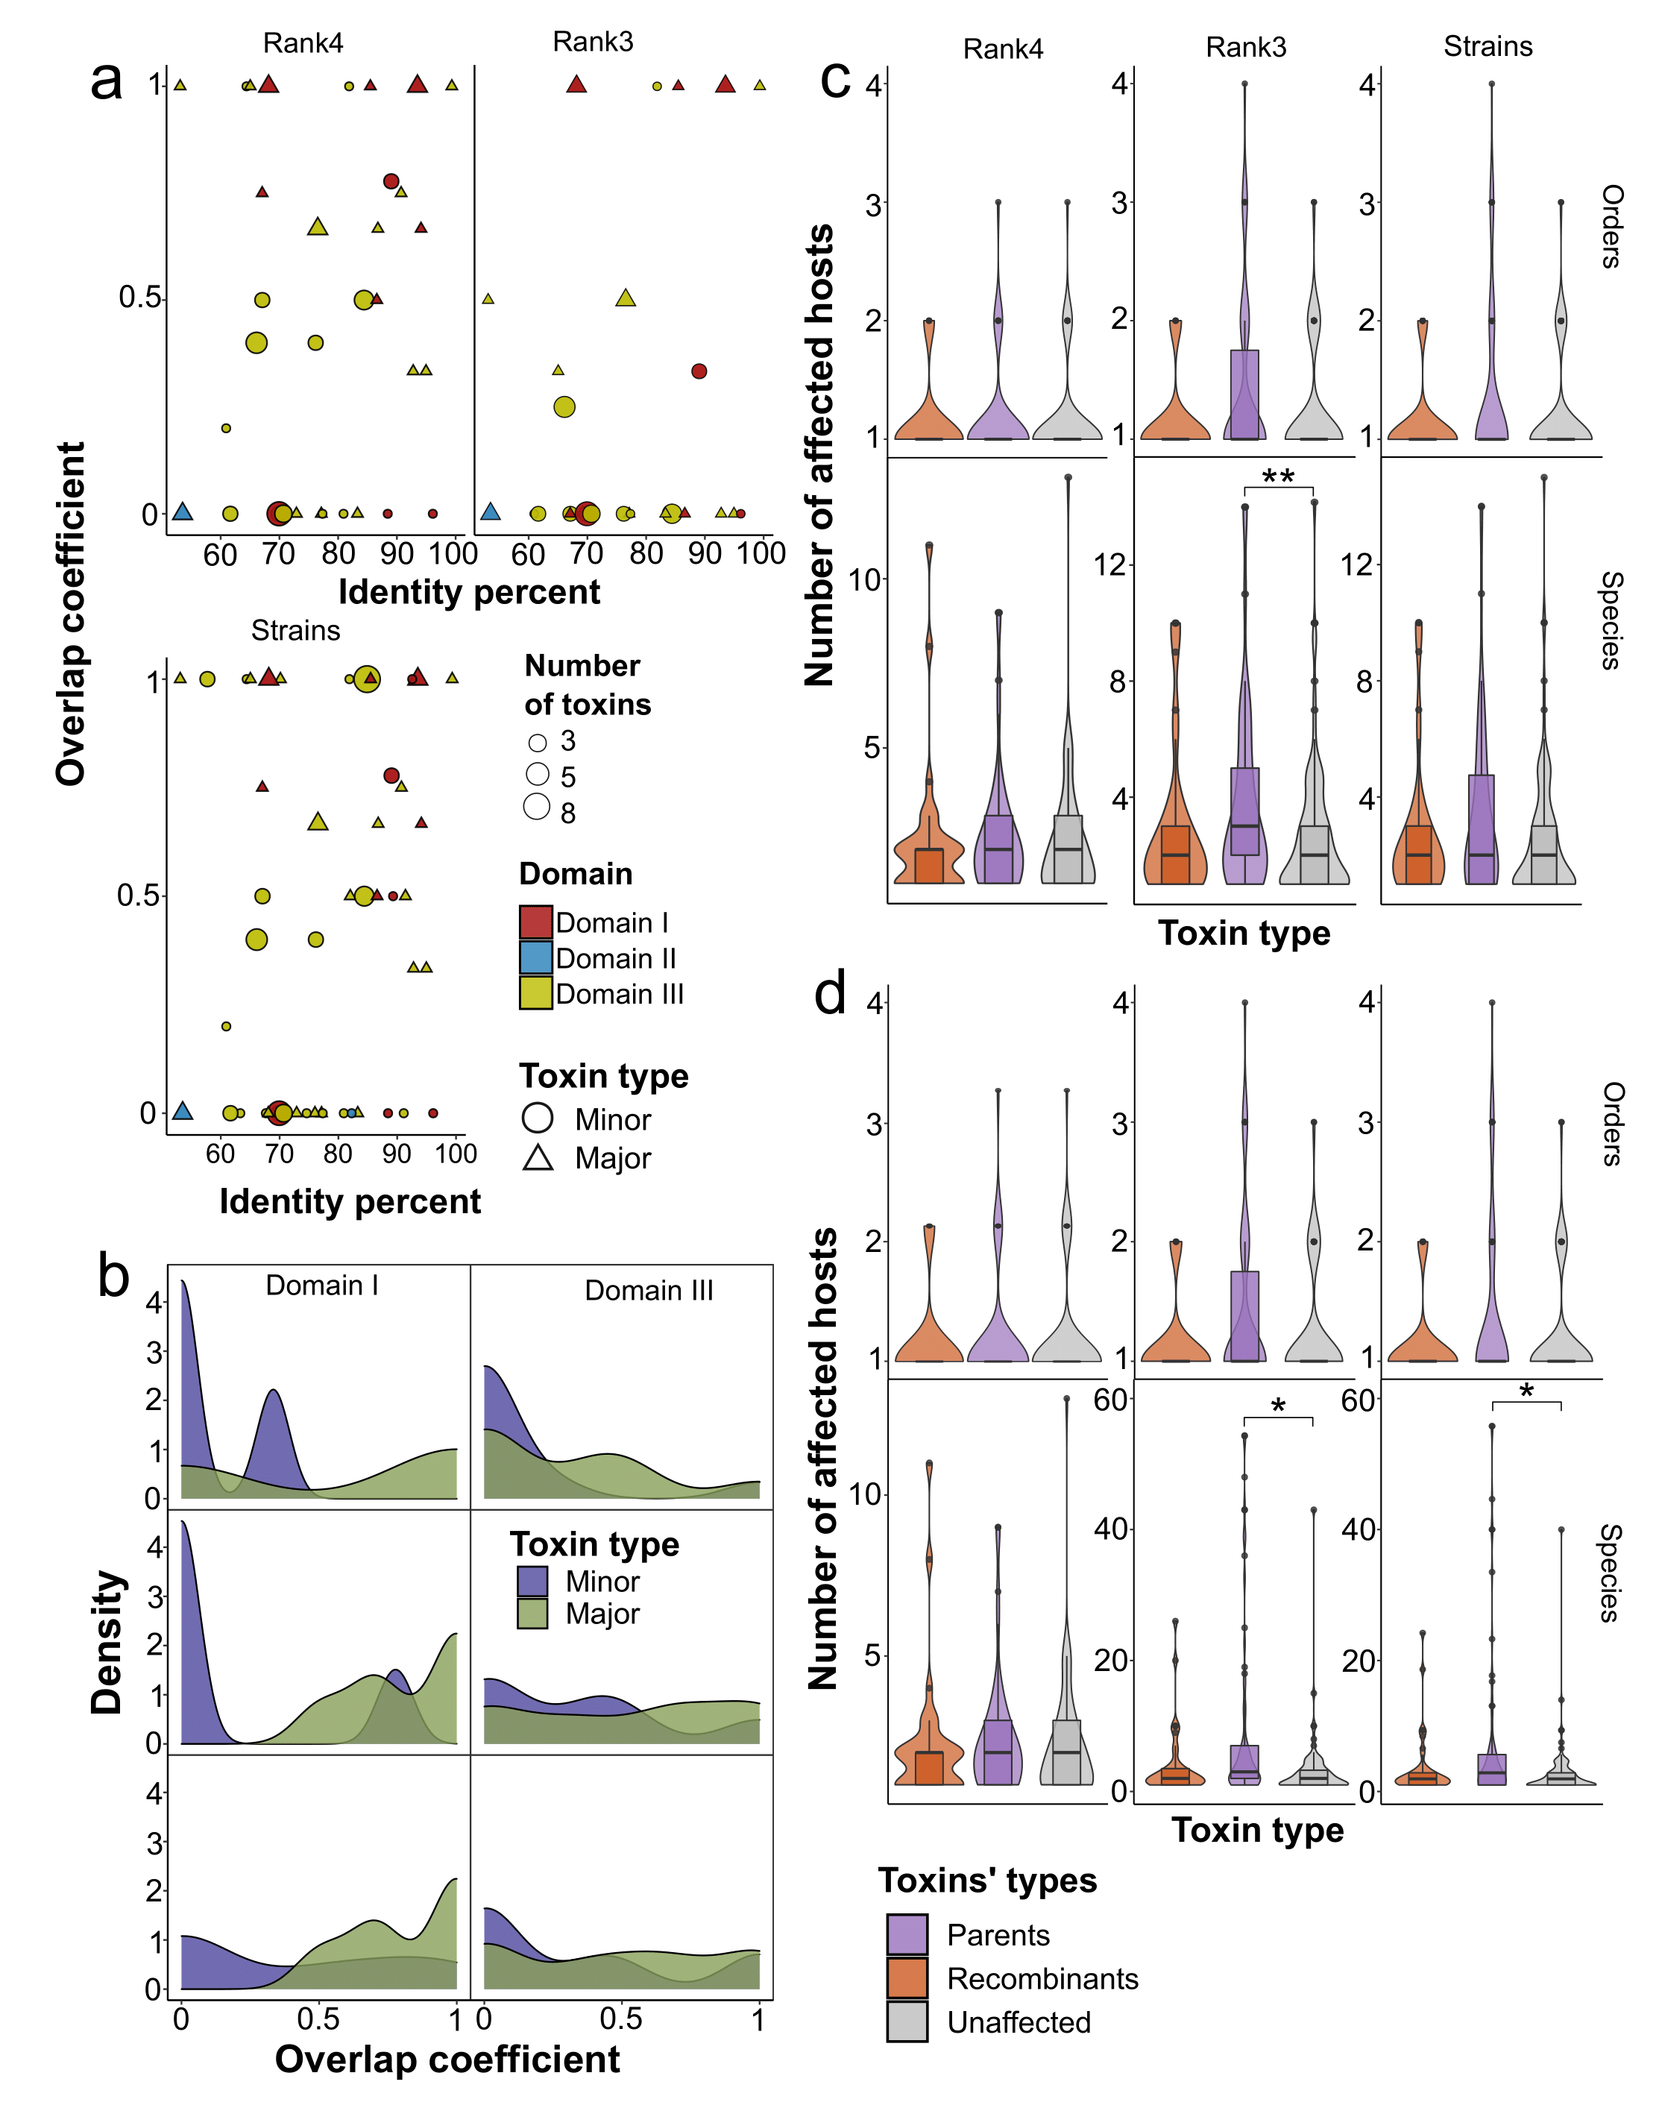

**Fig. S20**. The comparison between the composition and the number of affected hosts for parents and children within recombination events and toxins devoid of domain exchanges as well. (**a**) The relationship between the Szymkiewicz–Simpson coefficient (overlap coefficient), i.e., the intersection between the host species attributed to recombinants and parents divided by the size of the smaller set of hosts. Lots are based on the data either from the fourth or third ranks of toxins and strains. The size of the points is proportional to the number of toxins. The shape corresponds to parent types, and the color is determined by the transferred domain. (**b**) Density plots showing the frequency of overlap coefficient estimates within the events implying exchanges of the first and the third domains. The color of the plot corresponds to the type of parents, and the panels from top to bottom are determined by the sets of events dependent on the source of host metadata. The distribution for the second domain was unavailable to calculate, given the scarcity of the data. (**c**) The mean number of the affected host species and orders of different toxin types, namely recombinants, parents, and toxins without recombination signals determine the color of violins/box plots. Toxins that are associated with less than 15 species or all the proteins (**d**) were taken into account. Significant differences according to the Wilcox test with p-values adjusted using the Benjamini-Hochberg procedure are marked with asterisks.

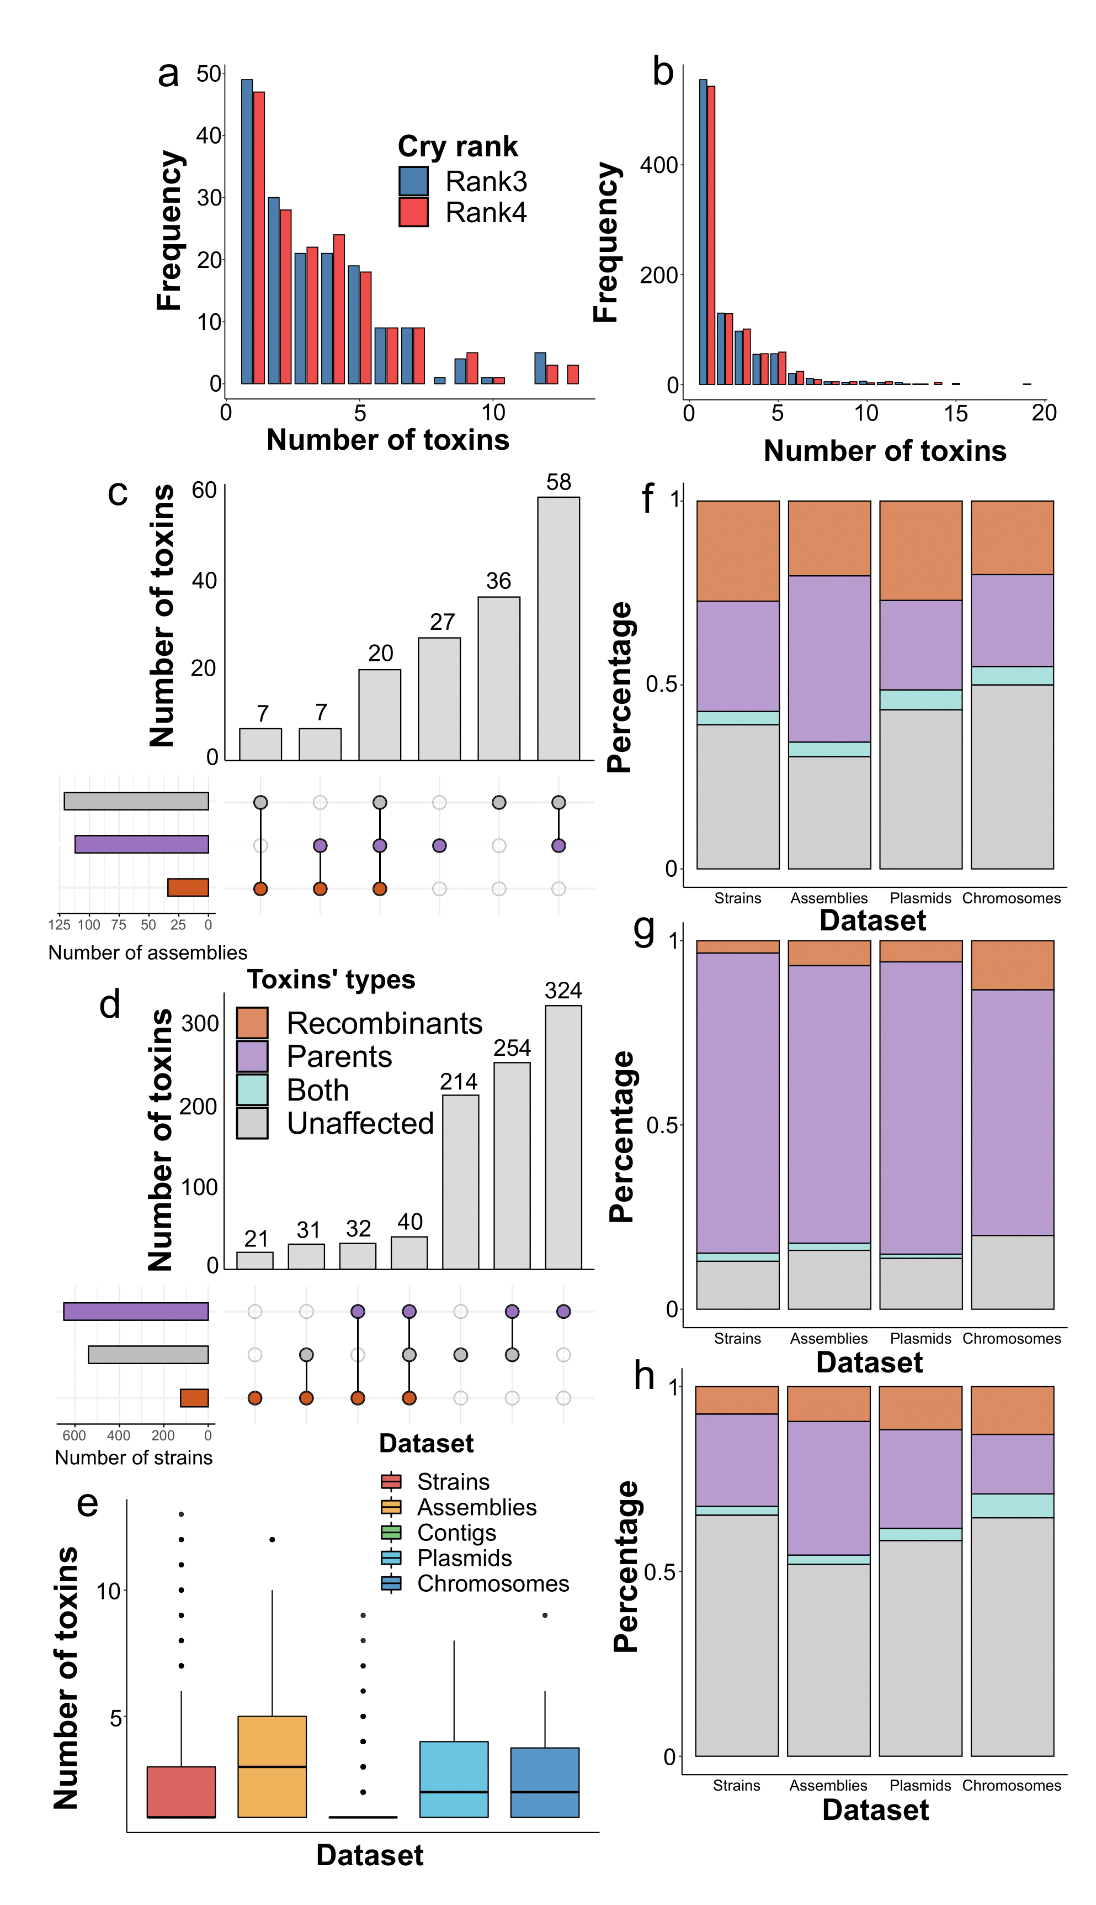

**Fig. S21**. The properties of assemblies and strains in terms of the types of toxins they contain in the context of recombination events. (**a**) The distributions of the number of toxins in the assemblies and strains (**b**) regarding the rank of the respective Cry proteins. (**c**) Upset plots displaying the number of assemblies and strains (**d**) in the context of toxin types they include. The respective instances are classified according to the composition of toxins, namely, parents, recombinants, and the unaffected Cry proteins. Intersections indicate that the set of assemblies/strains contains different types of toxins. (**e**) The mean number of Cry toxins within different datasets, namely, strains, assemblies, and genomic regions within the assemblies, single contigs, plasmids, and chromosomes. (**f**) The fraction of particular toxin types in the datasets containing recombinants, parents (**g**), and unaffected toxins (**h**).

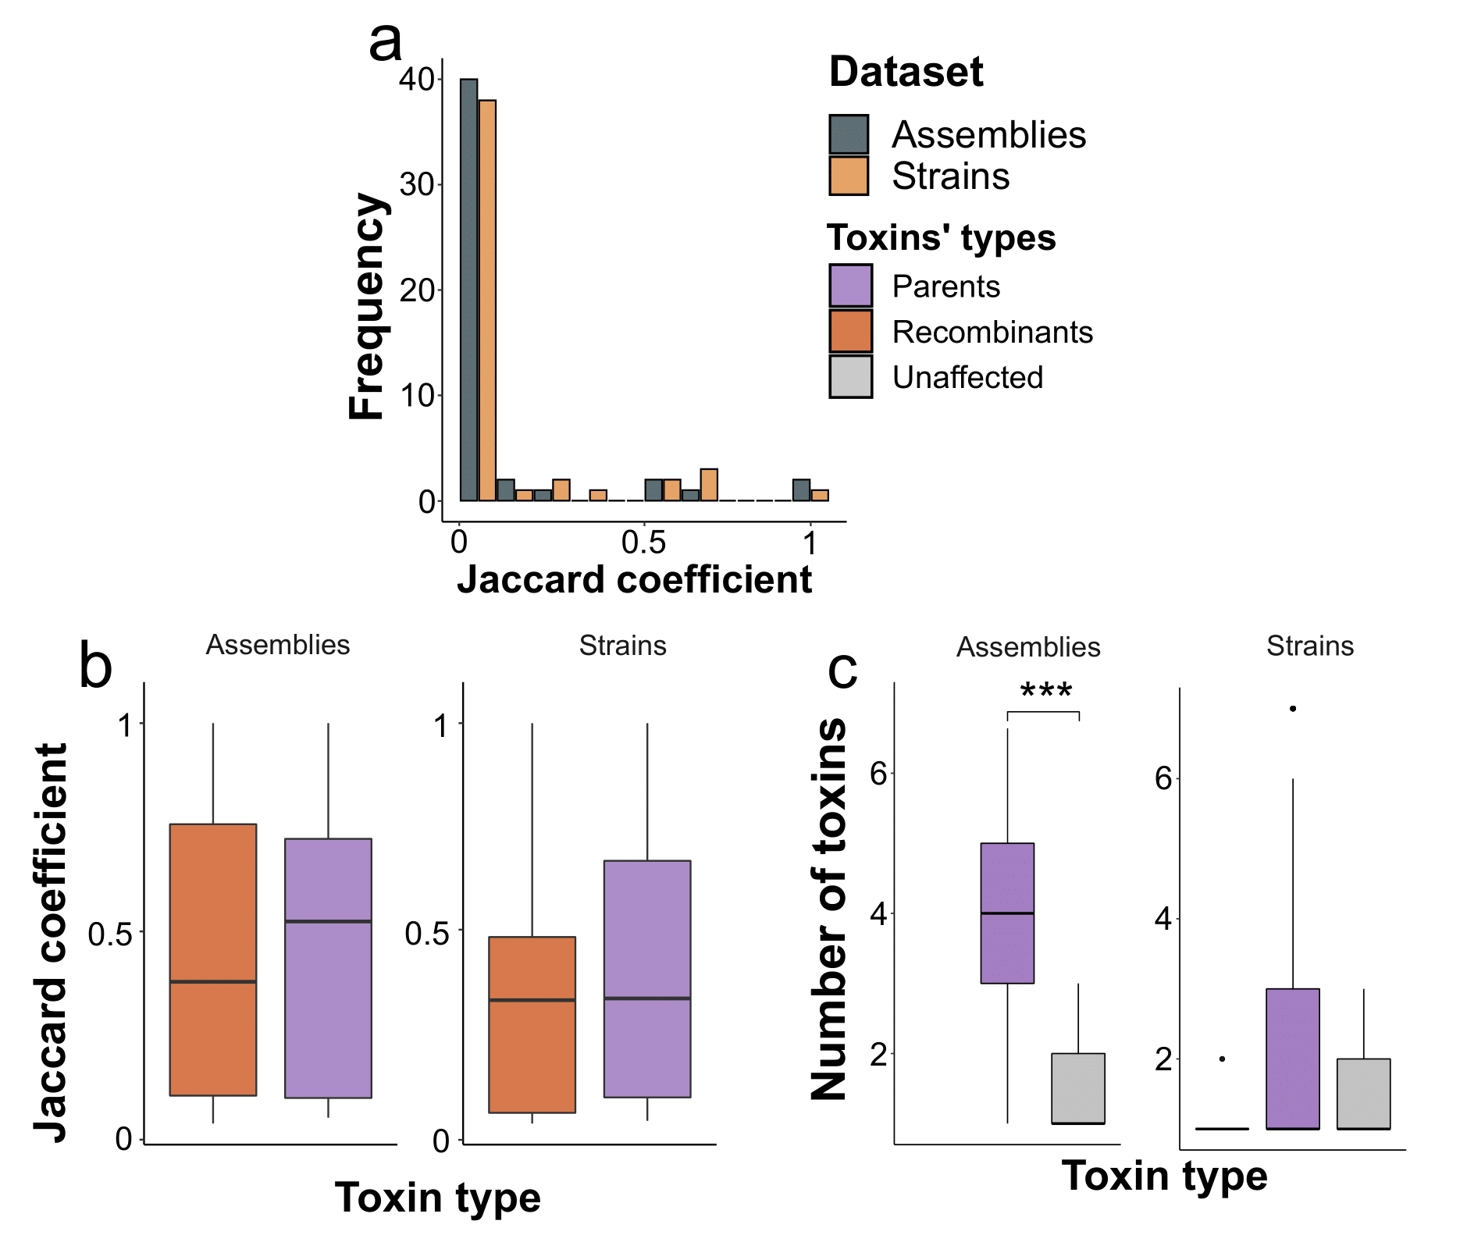

**Fig. S22**. Comparison between the amount and compositions of cry toxins belonging to strains and assemblies including participants in domain exchanges and the unaffected proteins. (**a**) The measure of similarity of all sets of toxins that strains and assemblies in which at least one parent is present. Event-wise comparisons using the Jaccard coefficient (the length of the intersection divided by the union of the sets) refer to toxins’ compositions in assemblies and strains attributed to minor and major parents of the recombination events. (**b**) Comparison between the above-described Jaccard coefficients exceeding zero when comparing recombinants with parents and only parents, respectively. (**c**) The number of toxins within assemblies and strains that contain toxins of the particular type exclusively such as recombinant, parents, and unaffected Cry proteins. Asterisks denote significant differences according to the Wilcox test with p-values adjusted using the Benjamini-Hochberg procedure.

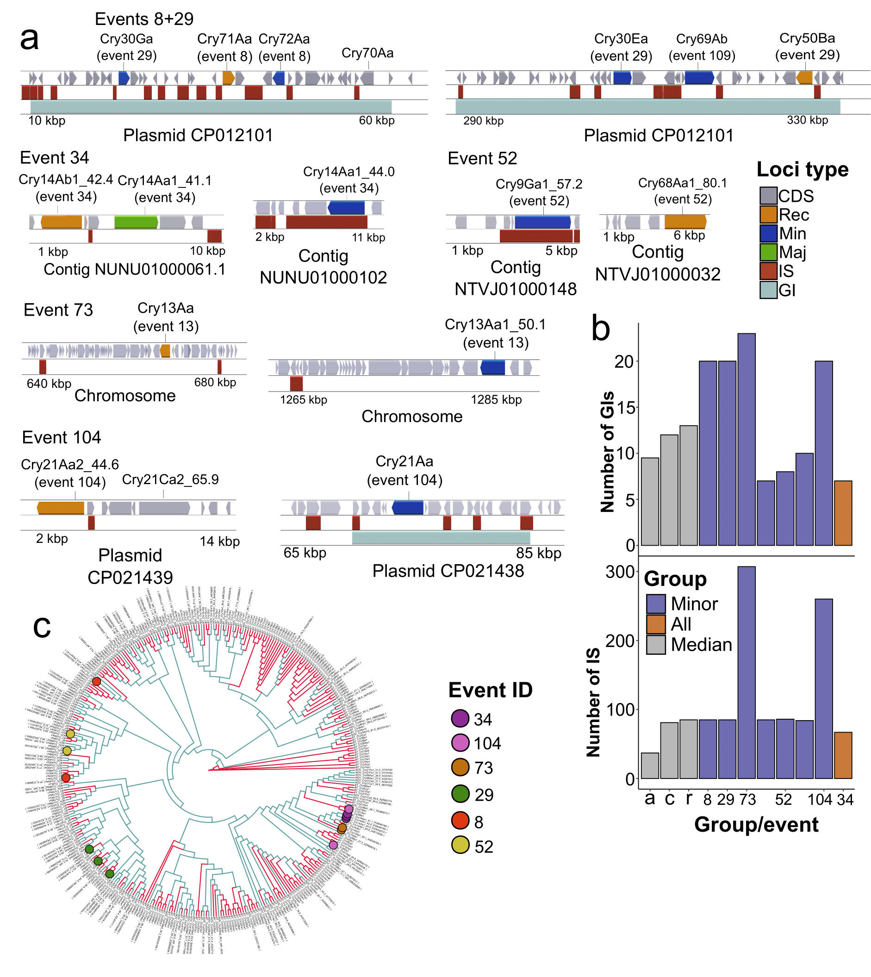

**Fig. S23**. Genomic context of genes encoding parents and recombinants from one event found in the same assemblies. (**a**) Loci surrounding recombinants and parents from individual recombination events. Shown are regions, plasmids, chromosomes, and contigs bearing the genes of interest. Three tracks are presented, namely, genes, insertion sequences (IS), and genetic islands (GIs). The color of the blocks on the first track corresponds to the toxins’ role in recombination events, e.g., major and minor parents, recombinants, and unaffected toxins. (**b**) Comparison of the total number of IS and GIs presented in genome assemblies that contain genes coding for recombinants and parents from the same events. Grey bars display median estimates for all assemblies studied, genomes with cry genes, and with toxins subjected to recombination, which are marked with letters ‘*a*’, ‘*c*’, and ‘*r*’ on the X-axis, respectively. Numbers represent IDs of recombination events. Event 52 was associated with genome assemblies, however, the genomic context was highly similar, thus, only one example is given. (**c**) Relative positions of Cry proteins on the full-lengthed partitioned phylogeny that co-occur in the same assembly. The color of circles defines individual recombination events.

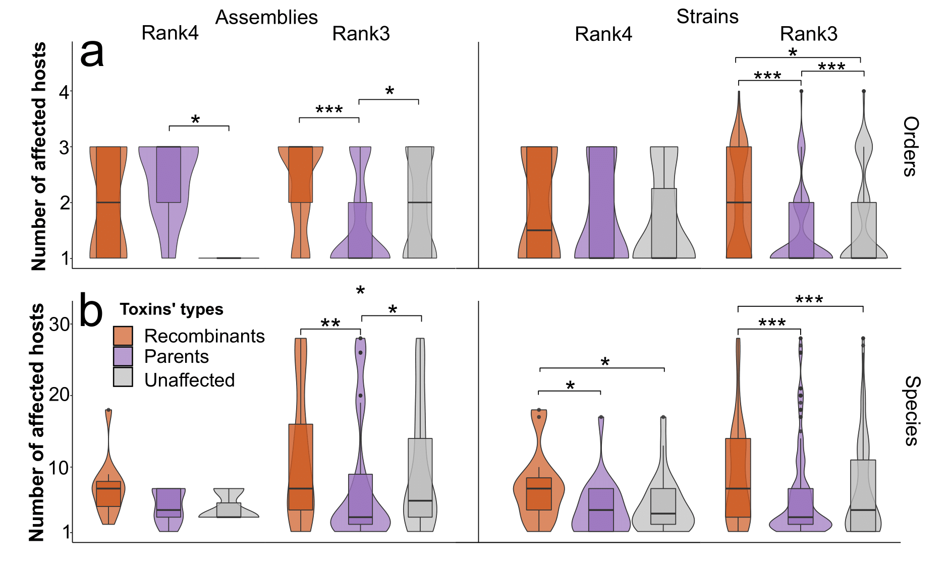

**Fig. S24**. The number of affected host species and orders by strains and assemblies with or without toxins subjected to domain exchanges. (**a**) Distributions for the number of affected orders and species (**b**) within the sets of strains and assemblies omitting the toxins associated with more than 15 species or considering them (**b**). The metadata taken is grouped according to the toxin ranks used. Significant differences according to the Wilcox test with p-values adjusted using the Benjamini-Hochberg procedure are marked with asterisks.

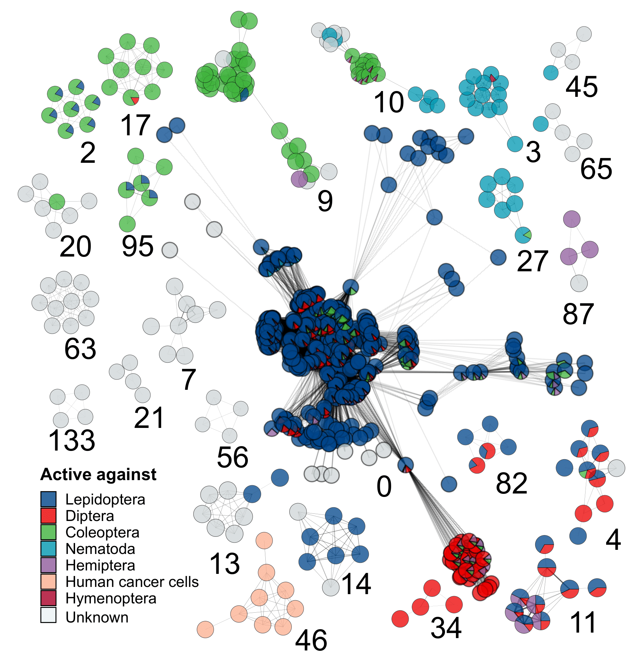

**Fig. S25** Weighted specificity-wise graph of strains sharing the common cry toxins. The nodes represent strains, whereas edges indicate that at least one toxin within the third rank is shared by the strain. The weight of the edges depends on the number of common toxins. The color of the node represents the overall proportion of species that are affected by the toxins found in the strain. Shown are connected components containing at least four nodes included. The IDs of the respective components are presented in numerical form.

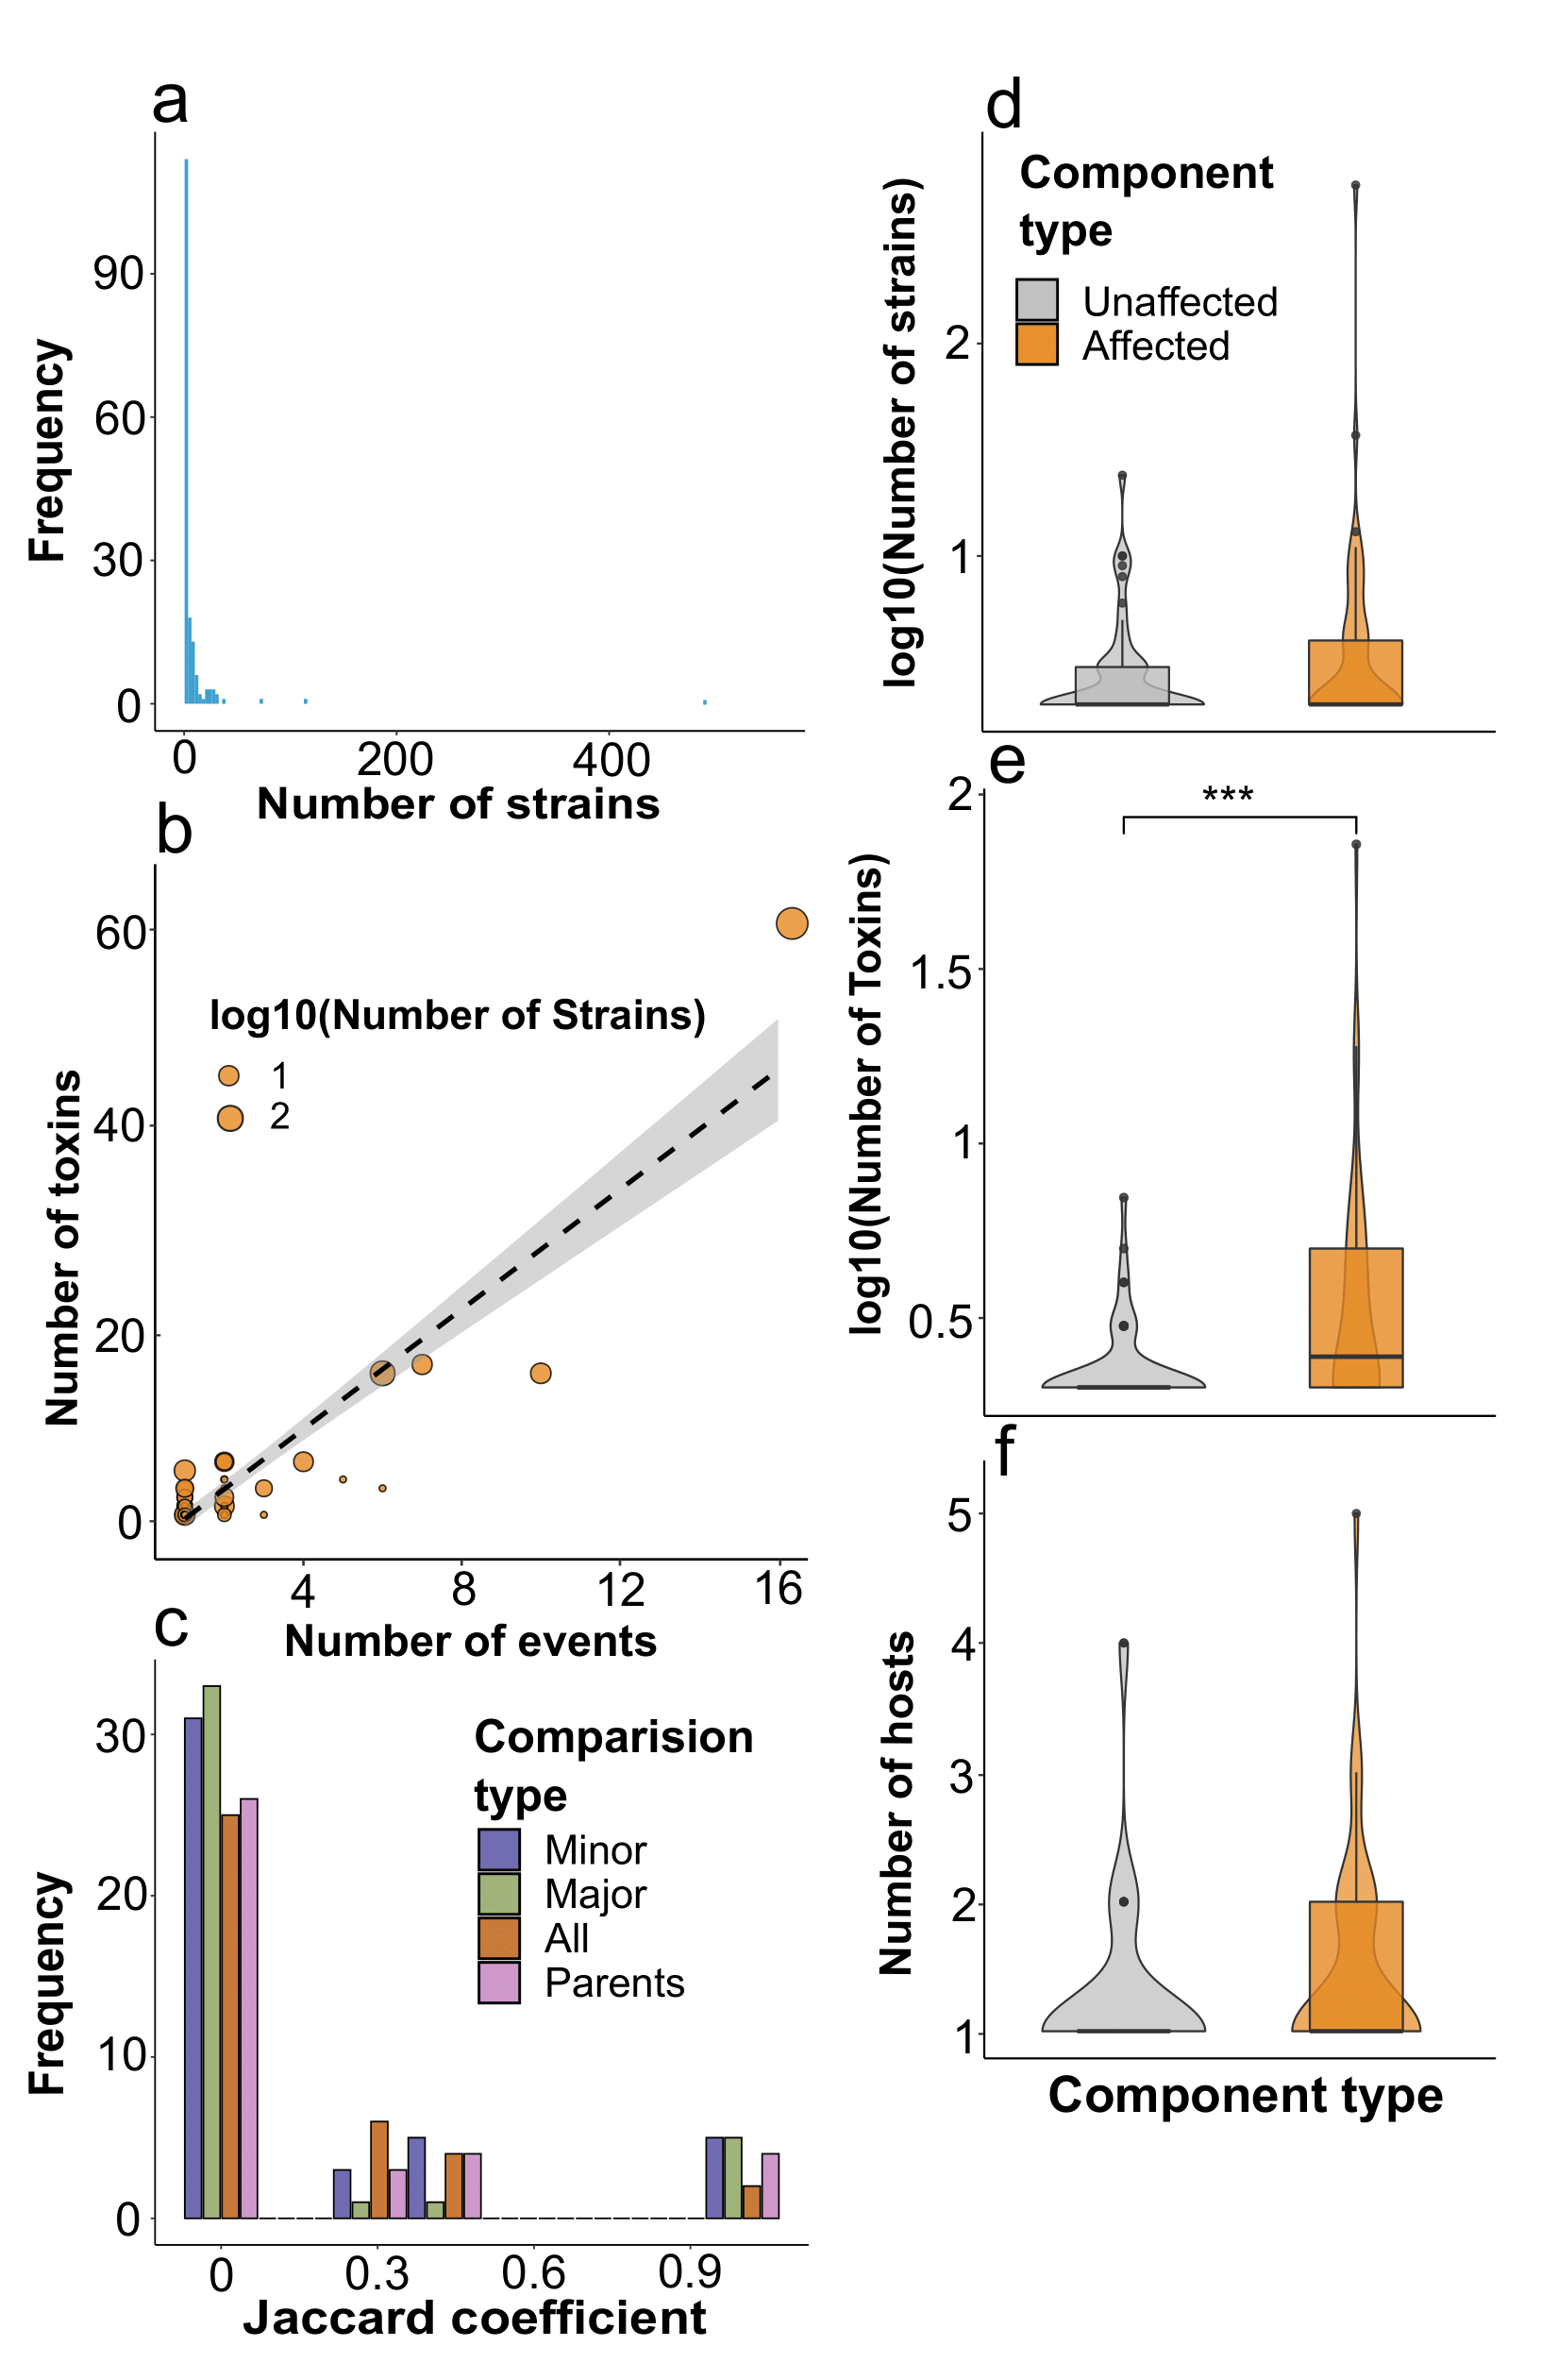

**Fig. S26**. Overall properties of connected components of the strains’ graph and comparison between components. (**a**) The frequency of connected components according to the number of nodes (strains) forming them, the arrow points to the largest component. (**b**) relationship between the number of toxins within the components and the number of recombination events, which are associated with them, the grey dashed line shows the dependencies estimated by the linear model. The size of the dots is proportional to the decimal logarithm of the number of nodes. (**c**) Distribution of the overlaps between the connected components in which parents and recombinants from the particular event reside. The color indicates the type of comparisons, namely, recombinants with parents, either minor, major, and all, and only between parents, respectively. The similarity is calculated using the Jaccard coefficient. (**d**) Comparisons between the components containing parents and children with the ones devoid of them in terms of the number of nodes (strains), individual toxin types (**e**), and orders affected (**f**). Significant differences according to the Wilcox test are marked with asterisks.

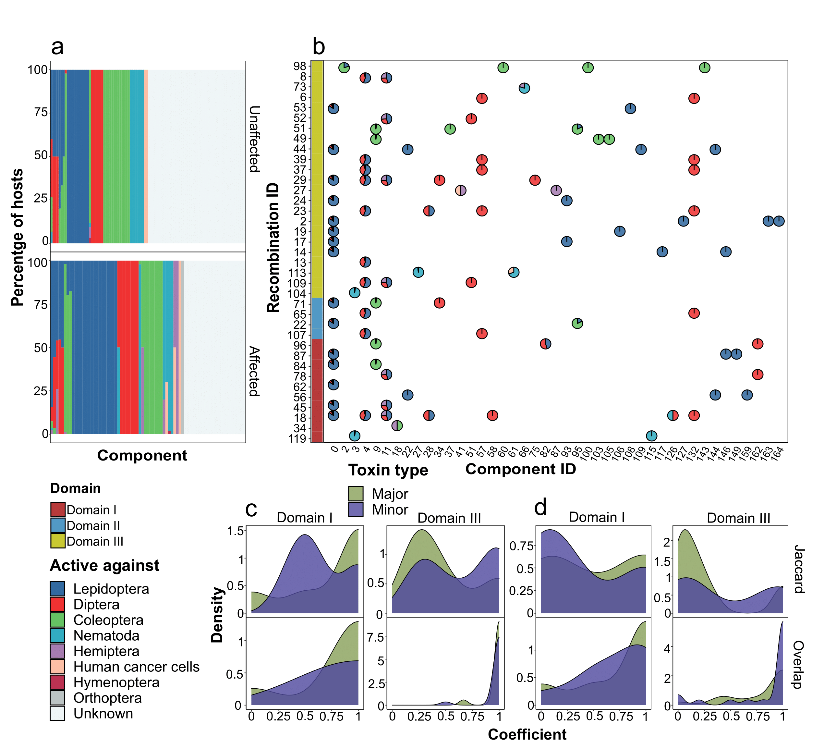

**Fig. S27**. Features of the connected components including recombinants, parents, and unaffected toxins in terms of the hosts they exert an effect on. (**a**) The percentage of host species attributed to their orders for strains within the connected components comprising toxins that have undergone recombination or not containing them. Plotted on the x-axis are individual components (**b**) The distribution of affected orders for the components associated with toxins from recombination events. The size of sectors of pie charts is proportional to the fraction of host species belonging to particular orders. The left adjacent panel indicates transferred domains within the events. (**c**) Density plots showing distributions of similarity estimates regarding the sets of orders and species (**d**) affected by recombinants and parents, either minor or major. The plots are presented only for the first and the third domains due to scarcity of the data regarding the second domain. Two similarity measures are considered, namely the Jaccard and overlap coefficients, respectively.

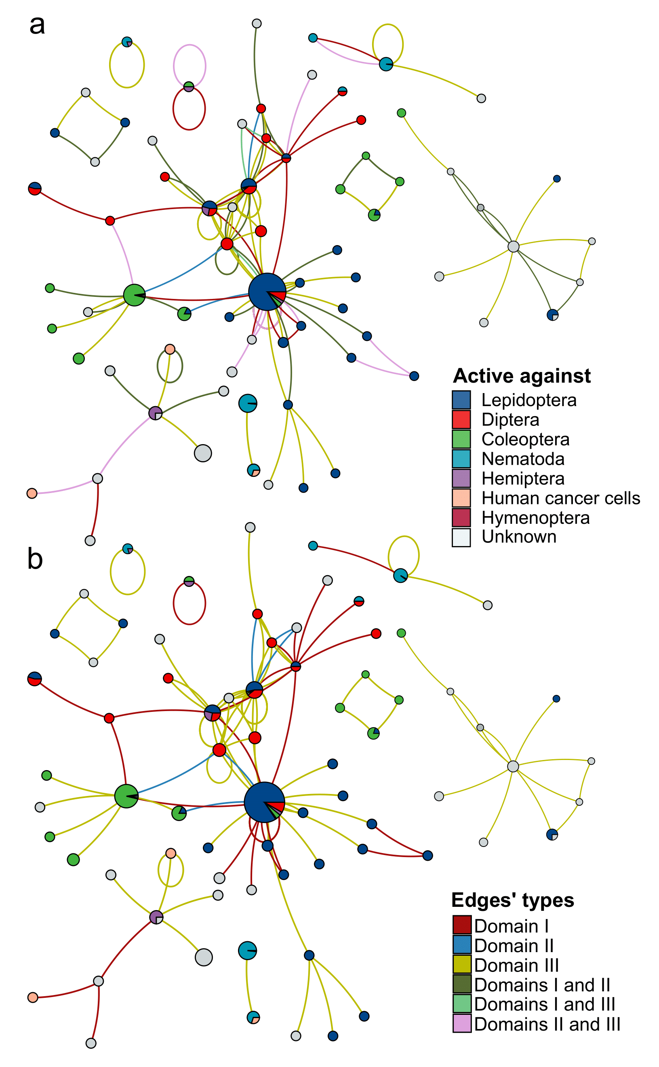

**Fig. S28**. Combined graph showing relationships between subpopulations of bacterial strains based on recombination events between toxins they produce. In the graph, nodes represent the connected components in the weighted specificity-wise graph of strains sharing the common Cry toxins (fig. S25). The color of the node represents the overall proportion of species that are affected by the toxins found in all strains within the connected components. Edges show domain exchanges between the toxins within the connected components colored according to the transferred domains. The edges represent all parents grouped according to domains (**a**) or the recombination events classified according to domains obtained from minor parents (**b**).

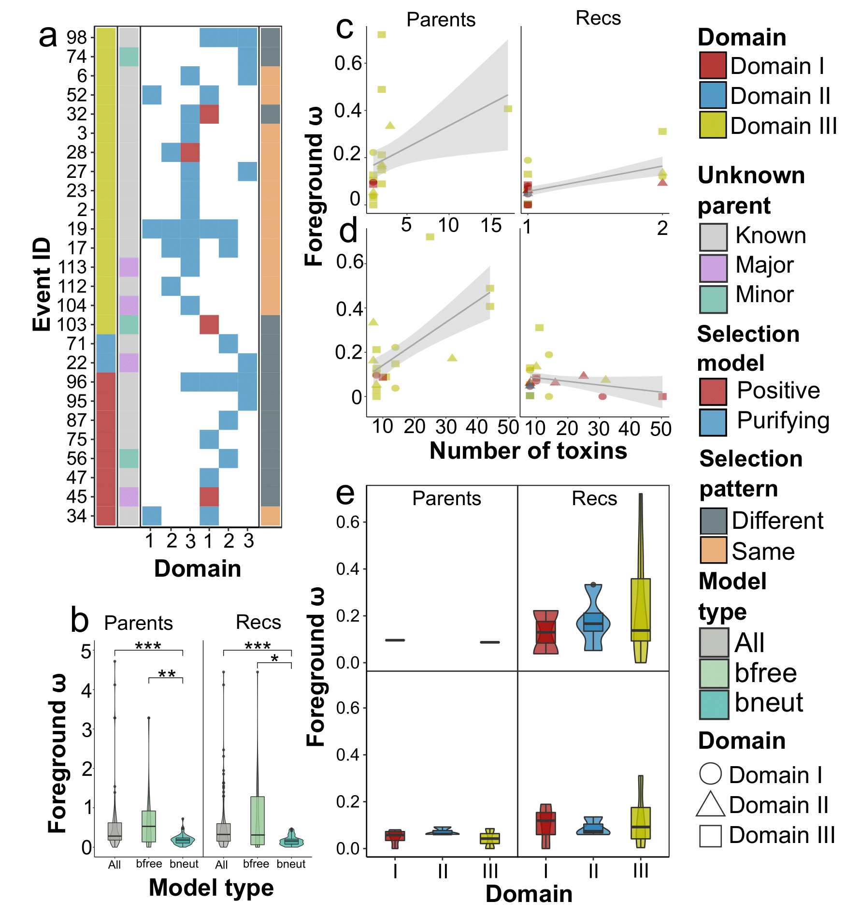

**Fig. S29**. Results of evolutionary selection assessment calculated on branches. (**a**) Optimal evolutionary models calculated on branches in which recombinant and parental sequences were marked. Here and in other figures the selection pressure was determined on the sequences of different domains independently. The heatmap shows the models reported for the particular domain. The left adjacent subpanels correspond to the domain that was transferred from the minor parent within domain exchanges and show whether a parent, either minor or major, is unknown, i.e., absent in the dataset analyzed. The color of the blocks represents the model chosen, namely, positive and purifying selection. The panel is divided into two blocks with the first one associated with parents and the second with recombinants, respectively. The right subpanel indicates whether for at least one domain a different selection pattern from the respective parental sequence exists. (**b**) Mean ω values (the nonsynonymous to synonymous substitution rate ratio, dN/dS) based on branch models. “All’ denotes non-filtered inferences, “bfree” indicates events for which the LRT (log-likelihood test) revealed significant differences from the neutral model, “bneut” marks the set of events for which selection within the foreground branches differs from the overall background (**c**) Relationships between ω and the number of marked toxins (recombinants and parents) or the total number of toxins (**d**) within the subtrees tested. The shape of the points indicated the domains for which models were assessed, while the color corresponds to the domain transferred during recombination. The ω value is positively and significantly correlated (p < 0.05 according to the linear model) with the number of marked toxins in the tree (both parents and recombinants), which, however, was backed only by several examples with a larger number of proteins (**c**). If all toxins are considered (**d**), significance is retained for parents only. (**e**) Average omega ω values based on branch models for the events affecting the first and the third domains of parents and children, respectively.

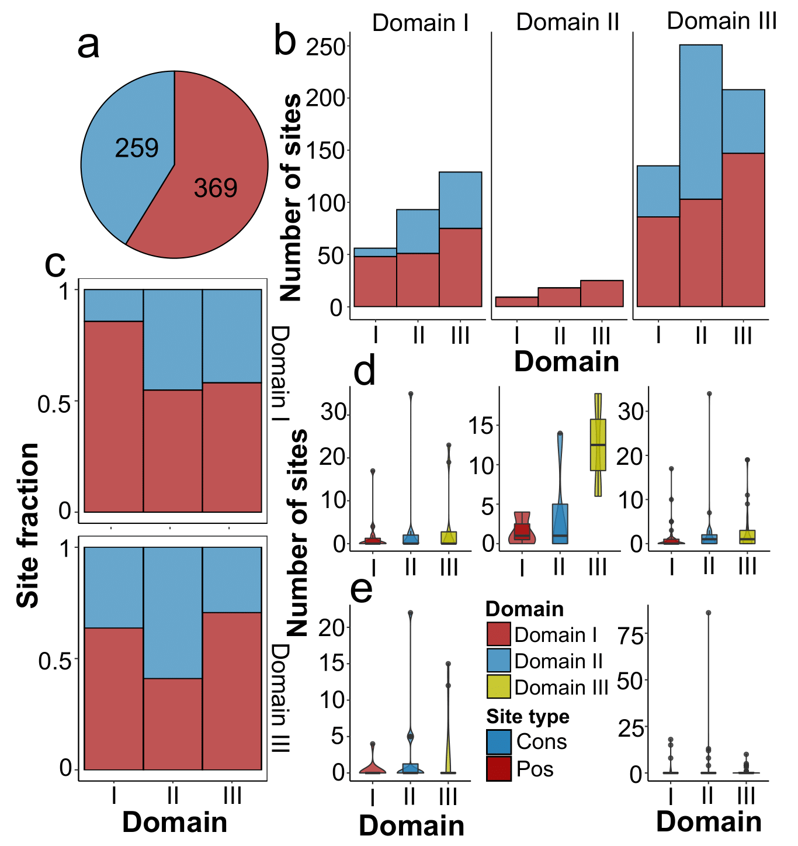

**Fig. S30**. Distribution of sites subjected to evolutionary selection according to site models. Here and in other figures the selection pressure was determined on the sequences of different domains independently. (**a**) The total proportion of conservative and positively selected sites revealed by best-fit site models determined by the LRT (likelihood ratio test). (**b**) The number of positively selected and conservative sites among domains within the sets of events grouped according to the transferred domain and the fraction of these sites (**c**) in exchanges of the first and the second domains. (**d**) The overall number of positively selected and conservative sites (**e**) for events affecting the first and the third domains. The color corresponds to the domain for which the selection model was determined.

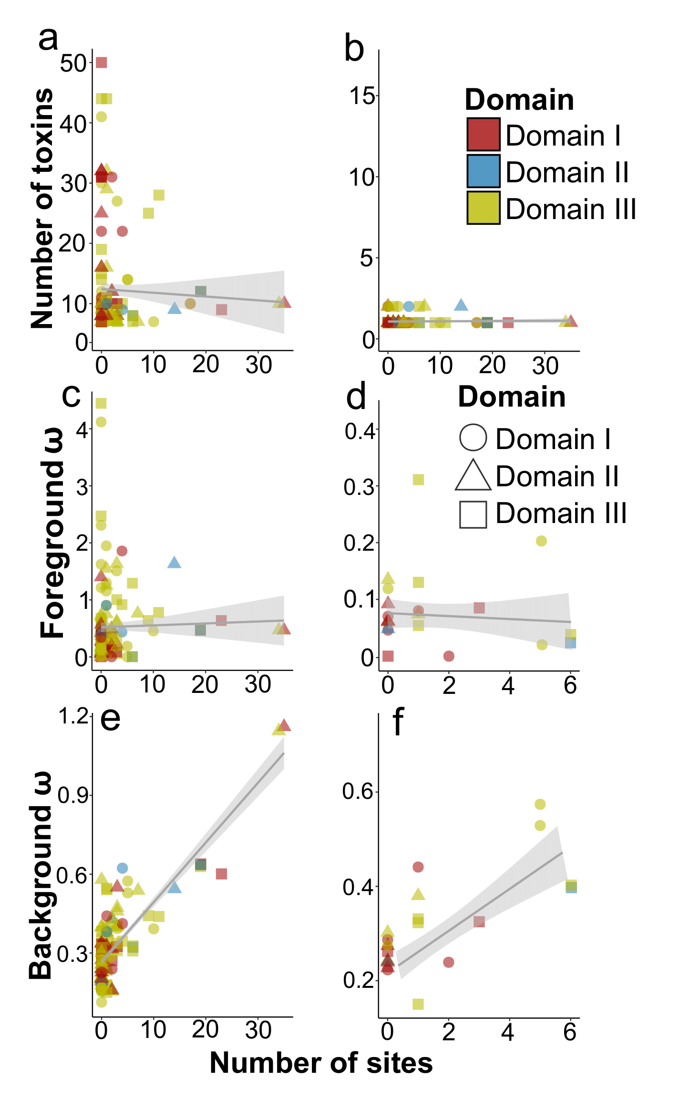

**Fig. S31**. Revealing factors possibly delineating the number of positively selected sites according to evolutionary selection models calculated on sites. Best-fit site models are determined by the LRT (likelihood ratio test). Here and in other figures the selection pressure was determined on the sequences of different domains independently. The shape of the points indicated the domains for which models were assessed, while the color corresponds to the domain transferred during recombination. (**a**) Relationship between the number of positively selected sites and the total number of toxins in the subtrees for which evolutionary selection was assessed, number of recombinants or parents (**b**), ω values (the nonsynonymous to synonymous substitution rate ratio, dN/dS) based on branch models within the foreground for all events (**c**) and those with a significant difference between branches (**d**). Figures (**e**) and (**f**) show the same estimates for background ω.

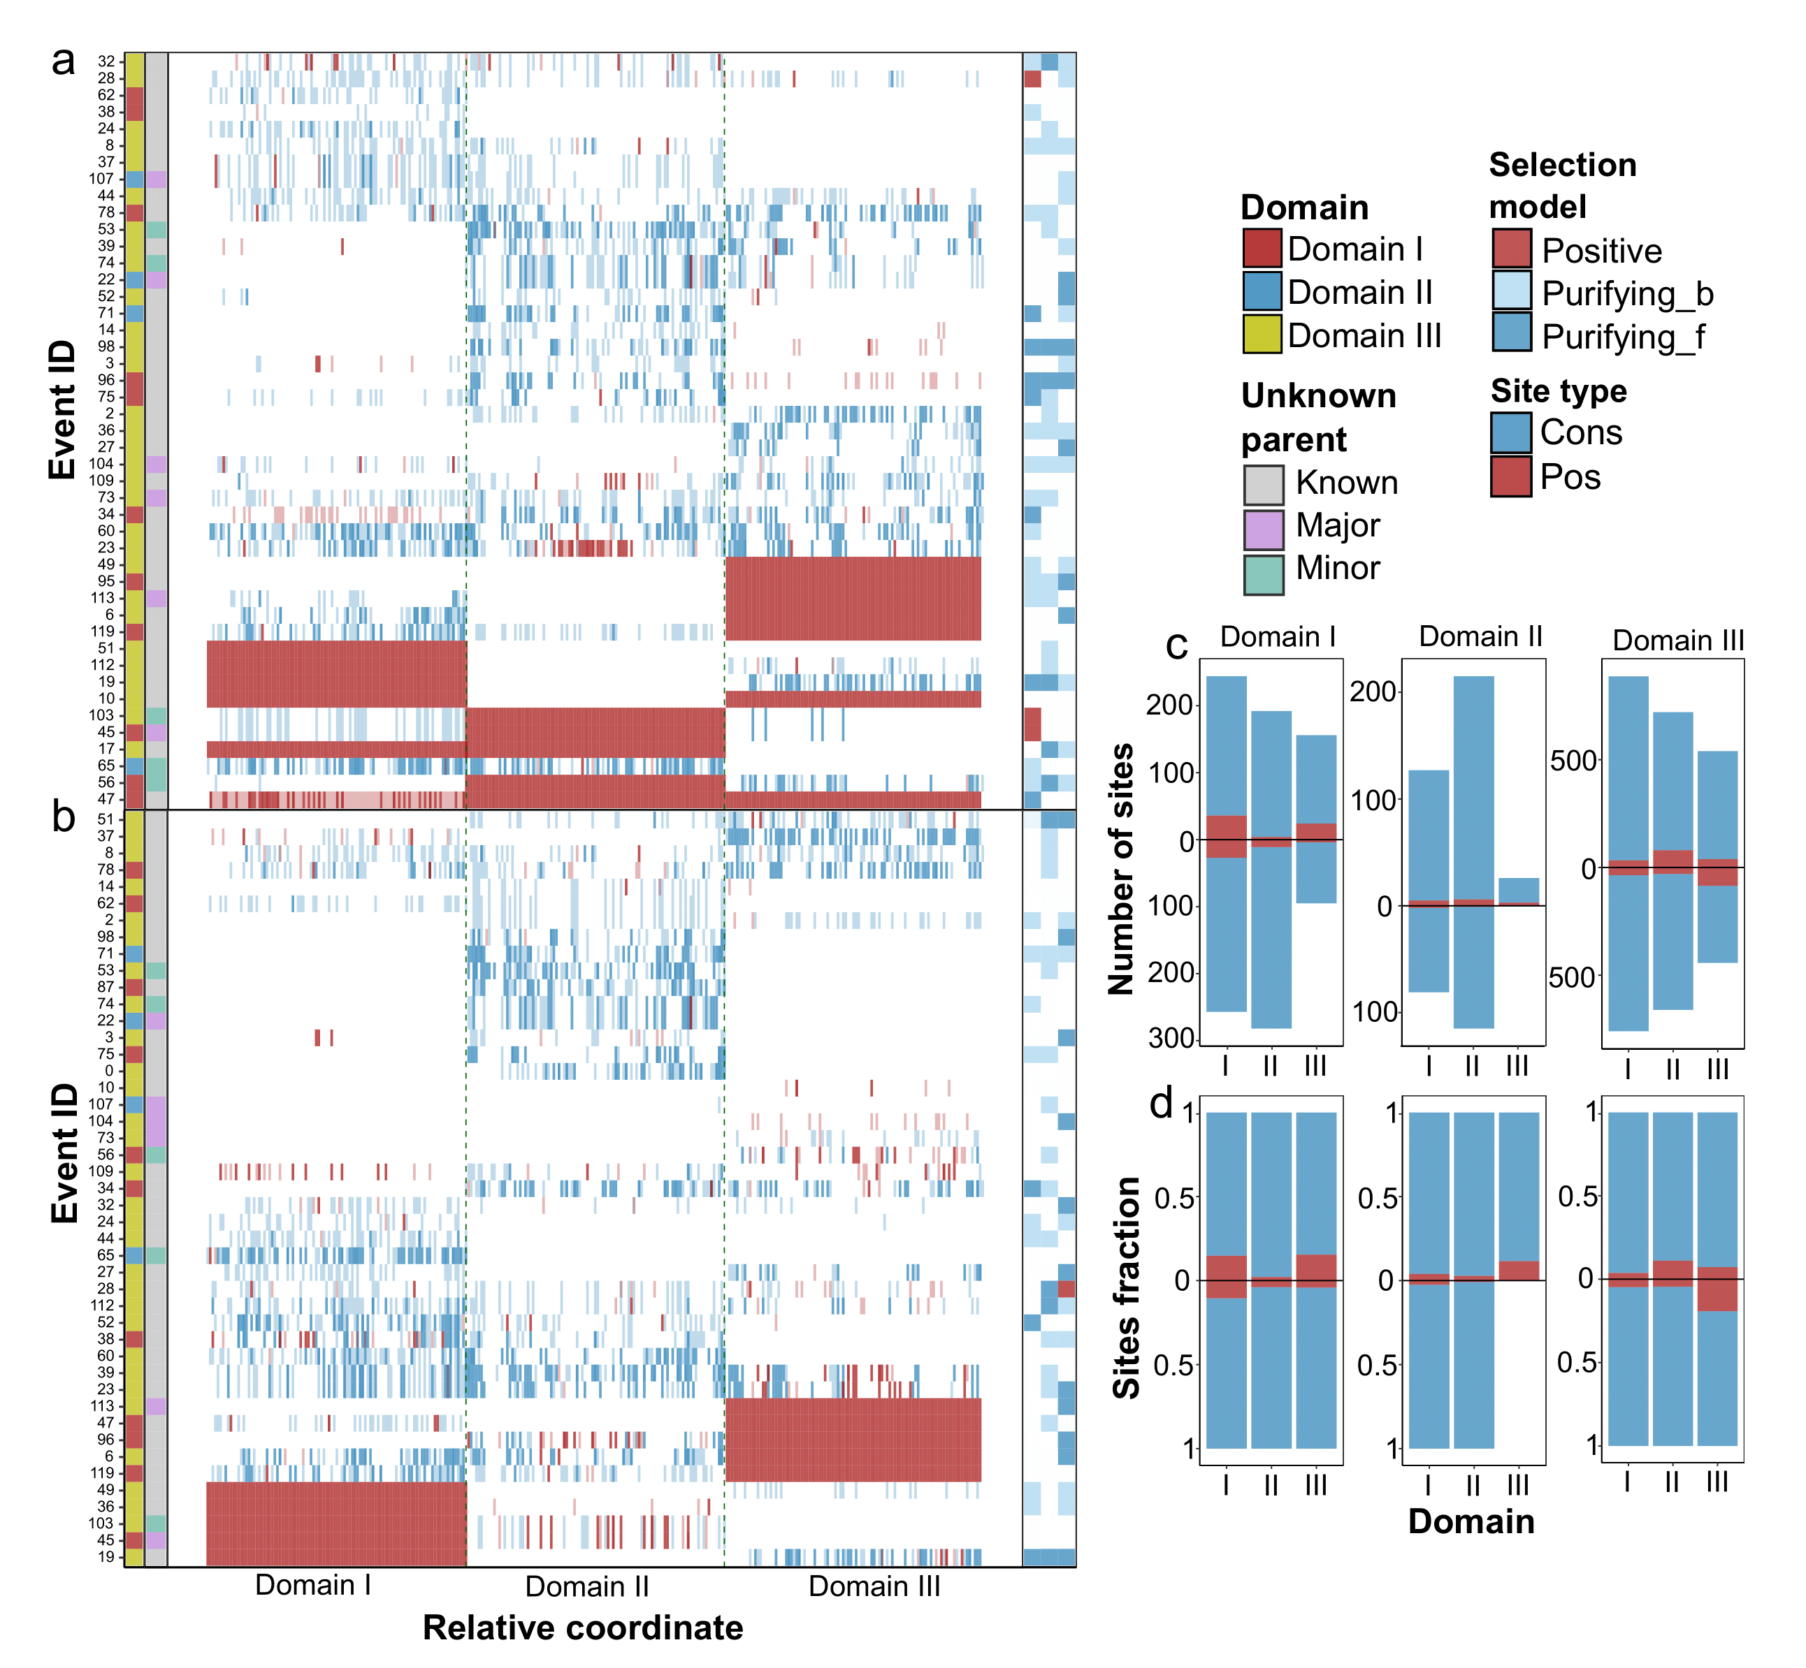

**Fig. S32**. Inferences of positively selected and conservative sites calculated on branch-site models in which recombinant and parental sequences were marked. Here and in other figures the selection pressure was determined on the sequences of different domains independently. (**a**) The heatmap sites with significant signals of evolutionary selection reported by best-fit branch-site models revealed by LRT (likelihood ratio test) in the cases when recombinants and parents (**b**) are marked. The left adjacent subpanels correspond to the domain that was transferred from the minor parent within domain exchanges and show whether a parent, either minor or major, is unknown, i.e., absent in the dataset analyzed. The site color represents if the site is positively selected, or conservative. The intensity of the color depends on the probability ranging from 0.95 to 0.99. the right subpanel indicates the significant model on branches with recombinants marked, namely, selection, and purifying selection either for the foreground or background only if the ω on branches is equal. (**c**) The number of positively selected and conservative sites determined using branch-site models among domains of recombinants and parents within the sets of events grouped according to the transferred domain and the fraction of these sites (**d**).

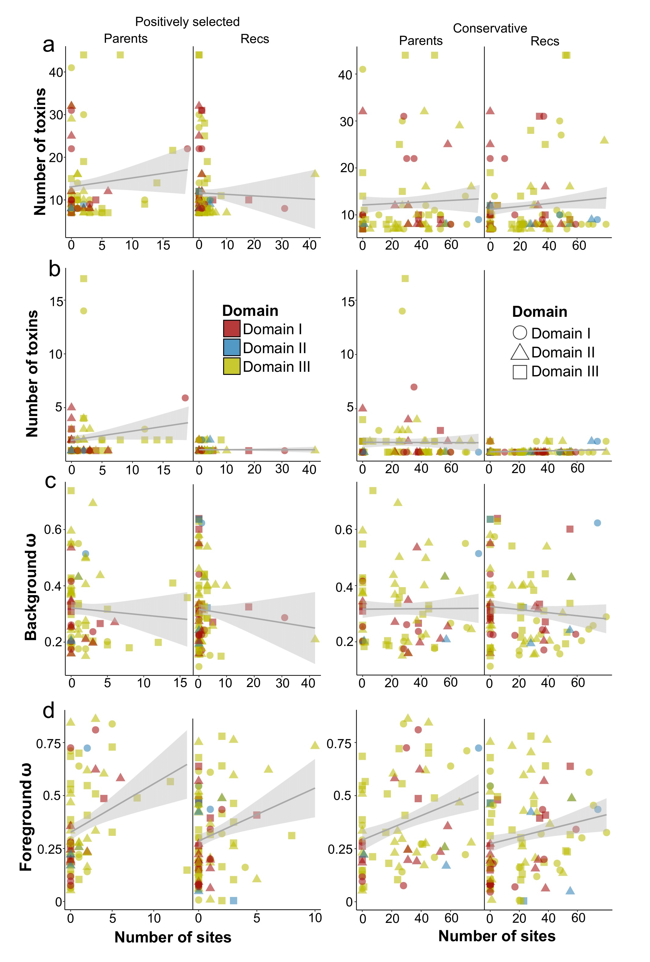

**Fig. S33**. Analysis of factors possibly delineating the number of positively selected sites according to evolutionary selection models calculated using branch-site models in which recombinants and parents were marked. Best-fit site models are determined by the LRT (likelihood ratio test). Here and in other figures the selection pressure was determined on the sequences of different domains independently. The shape of the points indicated the domains for which models were assessed, while the color corresponds to the domain transferred during recombination. (**a**) Relationship between the number of positively selected/conservative sites and the total number of toxins in the subtrees for which evolutionary selection was assessed, number of recombinants or parents (**b**), ω values (the nonsynonymous to synonymous substitution rate ratio, dN/dS) based on branch models within the background (**c**) and foreground in branches with marked recombinants and parents (**d**).

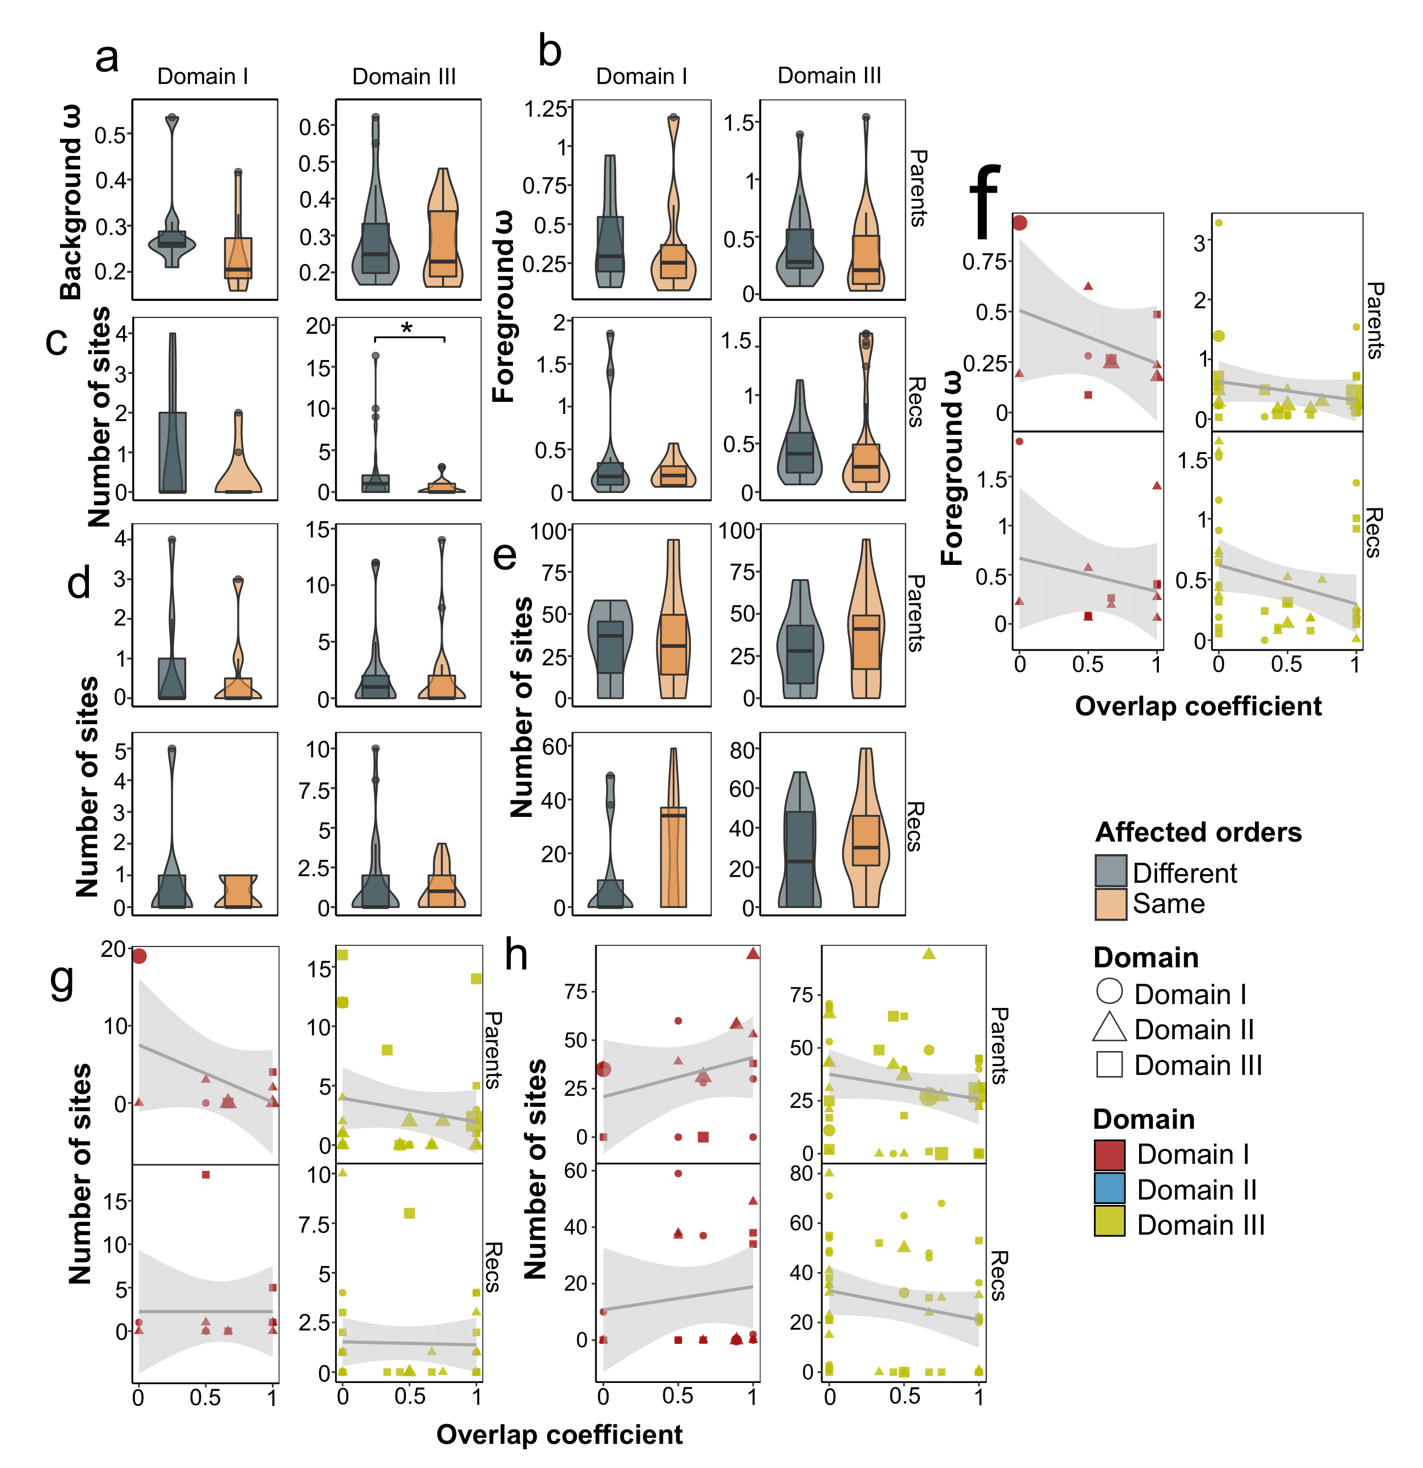

**Fig. S34**. Dependence between host specificity changes and features obtained when evaluating evolutionary selection. Best-fit branch, site, and branch-site models are determined by the LRT (likelihood ratio test). Here and in other figures the selection pressure was determined on the sequences of different domains independently. Relationship between changes in host orders (when at least one recombinant and one parent affect non-equal sets of orders) and ω values (the nonsynonymous to synonymous substitution rate ratio, dN/dS) based on branch models within the background (**a**) and foreground in branches with marked recombinants and parents (**b**), number of positively selected sites reported by site models (**c**), branch-site models (**d**), and the number of conservative sites (**e**). The relationship between the set of common species against which recombinants and parents are active and ω on foreground (**f**), and the number of positively selected (**g**) and conservative (**h**) sites revealed by branch-site models. The color indicates the domain transferred, while the shape of the dots corresponds to the domain for which the calculations were carried out.

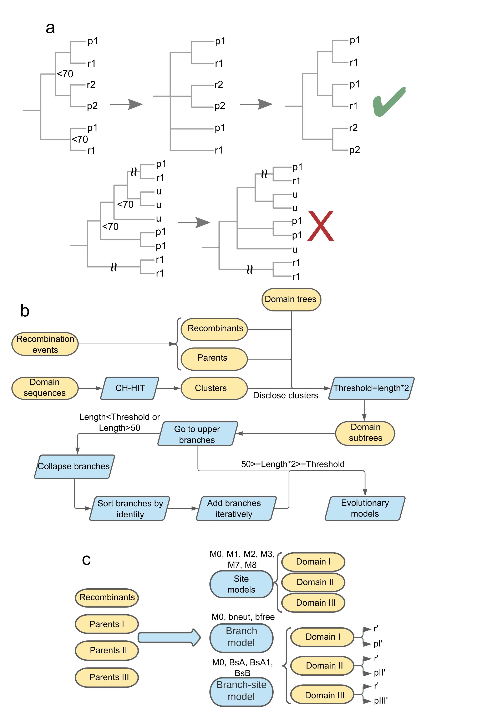

**Fig. S35**. Schemes of methodological approaches used in the study. (**a**) Filtering recombination events regarding the position of parents and recombinants on the phylogenetic tree. The analysis is performed for each domain-based tree independently, and the parent is determined by the type of transferred domain. In the first step, all nodes whose bootstrap supporting values are less than a predefined threshold of 70. In the next stage, we unified leaves with recombinants and parents in single branches by resolving polytomy. In case toxins missed by RPD4 predictions were found in the clades, the toxins were interpreted as parents of the individual domain according to the domain-wise tree. If the branches involving parents and recombinants were found in the root of the tree, their phylogeny was considered incongruent and the events were filtered out accordingly. Letters ‘r’, ‘p‘, and ‘u’ denote recombinants, parents, and unaffected toxins, respectively. (**b**) Data preparation scheme for evolutionary selection analysis. Domain-wise phylogenetic trees corrected for recombination as previously described were used to extract subtrees including the least common ancestor within the event. During the procedure, we disclosed clusters obtained with CD-HIT software. We then iteratively moved to upper branches and retained subtrees if their length exceeded the threshold defined as the number of recombination participants multiplied by two to get the background. If the procedure satisfied the threshold gained subtrees with more than 50 leaves, we screened all the subtrees with disclosed clusters arranged by the identity with the domain sequence of recombinants and iteratively added tree nodes until the required threshold was reached. The sequences in the trees were then aligned with MAFFT. Evolutionary models were selected using Modeltest-NG, and phylogenetic trees were reconstructed with RAxML-NG. The evolutionary selection was analyzed on the basis of the alignments and guiding trees using the ete3 package. (**c**) Shown are the evolutionary models tested. Data prepared during the previous steps were analyzed for each event separately. The best-fit models were chosen according to LRT (likelihood ratio test). Unlike site models, when examining branch and branch-site models, either recombinants or parents were marked as foreground branches and evaluated separately, which are displayed as apostrophes on the scheme.

**Supplementary text**

**S1. Supplementary Results**

**S1.1. Current databases contain toxins that can be included in the existing nomenclature**

To characterize the landscape of domain swaps between Cry toxins we first expanded the dataset through mining sequences bearing three functional domains and obtained 368 clusters accordingly with 110 of them sharing less than 95% homology with known sequences from the BPPRC database (Fig. 1b). We should admit that in our aim to expand the existing nomenclature, however, it might be useful to consider some instances for reviewing and naming. Current criteria for consideration imply either >95% identity with the existing proteins or experimentally demonstrated activity against invertebrates (2). While self-titled toxins found in genome assemblies such as cry13Ba1 (3) do not meet any of the criteria, some proteins like Cry3Aa12_81.9_AEZ53144.1 (4) were proved to form crystals and were toxic towards different hosts and worth consideration. The presence of Cry toxins in non-*Bt* species like *P. bifermentans* and *Paenibacillus popilliae* is a commonly known observation (5, 6). We, however, revealed the presence of these toxins in diverse species within the *Bacillus* genus, members of the Bacillales order, and, most intriguingly, *Clostridium* *botulinum* (Fig. S3a), which corroborates the existing studies (7, 8). These observations allow us to assume the possible common origin of these toxins.

**S1.2. Cry sequences show a high recombination rate**

We studied the recombination rate using ClonalFrameML, Gubbings, and fastGEAR which reported 13290, 369, and 1711 events, respectively (Fig. S10a-c, Tab. S18-20). The programs provided incommensurable ratios of effects of recombination and mutation (r/m), namely, 372.2 and 1.1 estimated by ClonalFrameML and Gubbings. Due to the high number of events, the latter seems to be an underestimation. A substantial incongruence might be explained by inaccurate predictions when dealing with extremely divergent and intensively recombining sequences (9). However, the abundance of the events corroborates the presence of extensive recombination between Cry toxins.

**S1.3. Linked recombination events suggest the natural diversity of Cry toxin sequences remains poorly studied**

The combination of two approaches, namely, adding parents from domain-wise phylogenetic trees per recombination events and creating the exchange graph was used for spotting linked events (Fig. S13, Tab. S23). In contrast to other events, toxins within such exchanges received each of the domains from distinct parents possibly implying that true major parents are absent in the dataset of currently available sequences of Cry toxins. Notably, two events involved the second domain, which suggests that such findings could arise from two sequential swaps of the first and the third domains. Since two other events in which the transferring of the second domain was more evident were present (Tab. S12), we do not exclude the probability of domain II exchanges, while they seem to be quite rare if exist.

**S1.4. Revealing conservative blocks and choosing an optimal clusterization method**

To study the sequence identity within recombination breakpoints, we selected recombination events without unknown parents and aligned the respective sequences to get the coordinates of breakpoints in parental toxins. Thereupon, we re-aligned the parents only and, through mapping to the initial coordinates, excised 100 b.p. flanking regions surrounding the breakpoints (Tab. S29). After that, we ran the rolling average function on the coordinate-wise per-site identity.

A more detailed picture of the event-wise distribution of identity scores was obtained by clusterization of the respective distributions. We opted for the most suitable clustering algorithm and distance metrics by determining the highest silhouette score. The best option implied cosine distance applied on rolling mean-corrected identity scores with the following hierarchical clustering (Fig. S16a-b, Tab. S30).

**S1.5. The available data on host specificity shows a skew in studying certain Cry types**

We collected host range data for 284, 184, and 148 proteins within the fourth and the third ranks, and strains, respectively (Fig. S18a). The number of individual assays predominantly included orders Lepidoptera, Diptera, and Coleoptera accounting for 75-85% of the examples (Fig. S18b, Tab. S34). For most cases, proteins and strains exhibited activity against a single order, whereas there were two notable instances such as Cry1Ba and the C18 strain related to four different orders (Fig. S18c, Tab. S35). A similar picture was obtained for species (Fig. S18d). However, three Cry toxin families, namely, Cry1Aa, Cry1Ab, and Cry1Ac being the most studied, were toxic to a broad range of host species ranging from 48 to 65 (Fig. S18d).

**S1.6. Using the host specificity data for the third rank of Cry toxins is more accurate due to sequencing errors**

Considering *cry* sequences in the fourth rank-wise rank led to overestimations sparked from sequencing errors, especially if *cry* genes of the strain were sequenced both by Sanger and NGS methods (Fig. S21a-b, Tab. S41). As a result, the extensive number of *cry* genes was reduced sufficiently if using the third rank, and we retained it for further examinations (Tab. S41).

**S1.7. Donors and acceptors of domains from multiple events co-occur in recombination-affected strains**

In order to understand, if and how the presence of recombinants in the isolates shapes the composition of toxins subjected to recombination or unaffected ones, and also characterize the patterns of co-occurrence of domain donors and acceptors, we classified assemblies and strains concerning the types of toxins they possessed and evaluated the inter-group intersections. Here and in further analysis, we considered the datasets in two ways: (i) the strains/assemblies were attributed to toxin types (parents, recombinants, and the unsubjected ones) if they comprised at least one toxin of a certain type regardless of the other types; (ii) the strains/assemblies containing exclusively one type were considered (e.g., those including recombinants but not parents and/or non-chimeric toxins, etc.).

We found that parents and children from diverse events tend to co-occur in the same assembly/strain (Fig. S21c-d). Of those harboring only a single type of toxins the ones containing parents prevailed (324 strains). The second largest group encompassed both parents and intact *cry* sequences (254 strains). According to median estimates of the content of Cry toxins, strains, and contigs were singletons, assemblies bore 3 *cry* genes, whereas plasmids and chromosomes – 2 (Fig. S21e). The observations reflect the absence of genome sequences for a plethora of strains, high fragmentation of assemblies, resulting in the lower number of *cry* loci related to contigs and strains, and a limited number of available *cry* sequences implying that multiple potential events are left undetected.

Unlike the data for reference toxins only, when summarizing which toxin types in a third rank-wise way are produced by the known natural isolates, we found that the fraction of recombination-affected toxins within the datasets reached 73% (Fig. 4b-c). Of note, the groups of interest prevailed in the datasets containing certain toxin types. More specifically, recombinants constituted 30%, parents – 79%, and unaffected by recombination toxins – 65% of the data within the respective subsets (Fig. 21f-h).

**S1.8. Genes encoding parents and children from the same events reside in close genomic regions**

We identified six events with five of them displaying recombinants with one of the minor parents and one with both types of parents (Tab. S46). Toxin-encoding genes were located either close to each other falling into GIs or in distant regions. In all the cases, the *cry* genes described were flanked by insertion sequences, and several strains were generally enriched in MGEs (Fig. S23a-b. Noteworthy, strain HS18-1 was associated with two events with *cry* genes residing within two large pathogenic islands (Fig. S23a). Genetic loci coding for toxins Cry71Aa (recombinant) and Cry72Aa (minor parent) from event 8 were linked with the first island, as well as Cry30Ga (minor parent) from event 29 with the respective child (Cry50Ba) being adjacent to another minor parent (Cry30Ea). The second pathogenic island also housed a minor parent from event 109 (Cry69Ab).

We also counted the overall number of MGEs in the genomes accordingly. Strains HS18-1, C15 (event 104), and MYBT18246 (event 73) were enriched with GIs, and the latter two were also rich in IS and exhibited nematocidal activities. The remaining assemblies were congruent with median values (Fig. S23b). The sequences of the domain donors and acceptors for all 8 events forming compact sister clades on the reference tree are relatively recent (Fig. S23c). The mentioned observations jointly illustrate that domain exchanges are associated with quick alterations in the toxins content of the strains facilitating further propagation of hybrids in other strains.

**S1.9. Larger connected components of the strains graph are enriched with toxins, affected hosts, and recombination events**

In the strain graph, 114 of the connected components were singletons (Fig. S26a). The largest component included 556 strains, 23 – 4 to 36 strains, and the rest – 2-3 strains (Tab. S48). The number of components possessing participants in recombination events was 73 (Tab. S49), and the largest one incorporated 16 events. Significant dependence (p < 0.01 as shown by linear regression mode) between the component’s size and the number of events was revealed (Fig. S26b).

The components devoid of recombination signals housed significantly fewer toxins (p < 0.01 according to the Wilcox test) than those associated with domain exchanges (Fig. S26d-f). The components were mostly linked with only single host orders related to toxins in them. Nevertheless, there were examples of generalist groups with plenty of strains (Fig. S25, Fig. S27a). The proportion of generalist strains was slightly higher in components with toxins undergone recombination (Fig. S27a). Moreover, this group comprised more components with at least one known host (Tab. S48), namely 63% vs. 50% (p<0.02 according to Fisher’s exact test).

**S1.10. The filtration of the events reduces the foreground ω estimates** **and does not affect the background**

The two-step filtration of the events based on the LRT significantly changed the mean ω for the foreground branches reaching 0.52, 0.71, and 0.16 for all events, non-neutral yet identical within branches, and with unequal rates in the foreground branches (Fig. S29b, Tab. S52) being associated with the number of marked toxins (Fig. S29c-d). This observation corroborates a markedly pronounced negative selection rate with the preservation of the acquired domains. At the same time, the mean ω for the background remained unchanged and hovered around 0.367. Notably, foreground ω within the threes built on diverse domain sequences exhibited no significant differences (Fig. 5b, Fig. S29e).

**S1.11. Site models associated with positive selection detection are prevalent in the dataset**

A total of 228 significant signals with one M1, 69 - M3, and 157 - M8 optimal site models were chosen corresponding to relaxation and positive selection for two latter models, respectively (Tab. S52). For event 95 associated with the M1 model, the enrichment with relaxed sites was reported, while for most cases belonging to the M3 model, relaxed sites were located on the boundaries between the domains opposite from the ones transferred from the minor parents (Fig. 5c).

**S1.12. The number of toxins within the analyzed clades is not associated with ω estimates**

To figure out the factors delineating the number of positively selected sites, we compared the respective values with the number of toxins and the ω, both background and foreground in trees reconstructed to calculate branch models for parents and recombinants. Neither the total number of toxins nor the marked ones have shown any impact on the number of sites possibly indicating that obtaining a tree for revealing selection on sites did nor not influence the assessment procedure (Fig. S31a-b, Tab. S52). The foreground ω, both when considering all signals and those with significant selection signals has no relationship with the number of sites (Fig. S31c-d), while a positive correlation with the background ω was detected (Fig. S31e-f).

Similar to site models, neither the amount of positively selected nor conservative sites were related to the number of all and marked toxins, which can be perceived as a further indication that the instances calculated reflect the evolutionary dynamics rather than the properties of subtrees chosen (Fig. S33a-b). Linear models also exhibited that the respective abundance of both site types was significantly and positively associated with the foreground ω (Fig. S33c-d).

**S1.13. Evolutionary selection does not reflect changes in affected orders**

First, we considered whether the parameters evaluated contribute to unequal sets of host orders between recombinants and parents. The inferred distributions provided some evidence, that the higher ω and amount of positive sites were associated with differences in host sets, while events with the same affected orders were enriched with conservative sites. However, the amount of data was not enough to gain significance except for the positively selected sites according to site models only (Fig. S34a-e, Tab. S52).

**S2. Supplementary Discussion**

**S2.1. Domain exchanges often accompany the evolution of bacterial toxins**

Current studies reported the SUKH superfamily of nuclease toxins combining C-terminal nuclease domains with N-terminal domains associated with secretion (10), *Clostridium botulinum* C2 toxin resembling C3 aside from NADbinding core (11), *Clostridioides difficile* TcdB toxin with multiple homologous recombination events generating new subtypes (12), mosaic LktA and LktB leukotoxins of *Mannheimia haemolytica* and *Pasteurella trehalosi* (13), and *Streptococcus salivarius* secrete glucosyltransferases (14). Formation of hybrid toxins in prokaryotes, therefore, provides an adaptive advantage, hence the exchange of functional domains through recombination might be a common mechanism of evolution of pathogenicity determinants.

**S2.2. Events within non-*Bt* species imply a common origin of Cry toxins**

We can conclude that not only does our computational approach confirm the existing examples of domain swaps but also sufficiently extends the list of chimeric toxins. In addition, there were several toxins in other species, namely, *Paenibacillus sp.*, *B. mycoides*, and *B. cereus* marked as parents in some events that were characterized either with larger amounts of toxins or domains of unknown origin (Tab. S54).

**S2.3. Computational predictions of recombination events corroborate known examples of chimeric toxins**

The first *cry* gene was sequenced in 1985 (15). Only a year later, when comparing sequences of crystal protein-encoding genes of *Bt* strains HD1 and HD73, Höfte et al. suggested that homologous recombination between genes occurs during the evolution of Cry toxins (16). Lately, Almond and Dean conducted experiments to figure out the reasons behind the low diversity in domain composition of the Cry1Aa family (17). After the construction of chimeric sequences from genes encoding Cry1Ac, Cry1Aa followed by transformation into *Bt*, intensive degradation of chimeric products by intracellular proteases was found, allowing us to propose that the respective exchanges lack evolutionary benefits (17). These observations corroborate our results inasmuch as these toxins have not been detected in the same events mainly serving as donors of domains I and III for other proteins. When the *cryX* gene (later designated *cry9Ba*) was sequenced, Shevelev et al. noticed its partial similarity with *cry1G* localized downstream and suggested recombination events to play a role in the emergence of these toxins (18). With more data available, our findings showed that Cry1Gb is a donor of domain III for toxin Cry9Ga underpinning evolutionary relationships between Cry1 and Cry9 families. Recently, an exchange of the domain I was reported for Cry2Aa17 receiving part of its sequence from Cry2Ab (19). Our observations also included two events implying swaps of domain I within the Cry2 group, namely Cry2Am being a chimera of Cry2Al (source of domain I) and Cry2Ag together with Cry2Ab as well as Cry2Ai receiving the first domain from Cry2Ac and two remaining from Cry2Aa.

**S2.4. Insertion sequences govern the propagation of *cry* genes**

Cry-encoding genes tend to reside in plasmids; thus, exchanges of *cry*-carrying plasmids frequently occur in *Bt* isolates, especially in the adaptive clades (44) with occasional inter-plasmid recombination (45). IS, particularly of the IS231 family often flanked *cry* genes (46). They might induce recombination causing the inclusion of genes into chromosomes or plasmids causing new combinations of toxins (47). Genes coding for Cry1 proteins with IS surrounding them form cassettes being the smallest mobile unit carrying insecticidal factors derived from the pathogenicity island disrupted by insertions (48).

**S2.5. Experimental studies show changes in the toxicity spectrum after domain shuffling**

Domain I exchange between Cry1A, Cry1C, and Cry1E sparked the formation of chimera non-toxic to *Spodoptera exigua* and *Plutella xylostella* (23), while the respective exchange between Cry9Aa and Cry1Ac, contrarily, increased the activity against *Helicoverpa armigera* fivefold (24). The transfer of the third domain from Cry1Gc to Cry1Ab magnified toxicity to *Chilo suppressalis* (25). This technique applied to Cry1Ac and Cry1Ca made a hybrid toxic to *Spodoptera frugiperda* unlike non-lethal parents (26).

**S2.6. Toxins of Cry32 and Cry7 families are prospective biopesticides with multiple pesticidal activities**

Members of the abundant Cry32 class were reported to be toxic against Lepidoptera, Diptera, and Nematoda, and they belonged to 5 recombination events implying that this Cry group is highly promising and deserving of further investigations. Another prospective Cry family is Cry7 forming a distinct connected component in a host-wise strain graph (Fig. S25). While the host spectrum of these toxins remains unknown, they were reported to get certain domains Cry7Ca1, the only known protein to act against *Locusta migratoria manilensis* Orthoptera (27). Therefore, the Cry7 family on the whole deserves testing for anti-orthopteran activity as a prominent source of possible biocontrol agents.

**S2.7. Negative selection frequently accompanies the evolution of bacterial symbionts and pathogens**

Multiple rounds of recombination events in major antigenic protein 1 (*map1*) family genes of pathogenic *Ehrlichia ruminantium* led to new loci, the most successful of which were kept by purifying selection (28). The same observations were made in the genomes of symbionts *Rhizobium* (29) and *Verminephrobacter* (30).

**S3. Supplementary Methods**

**S3.1. Initial data acquisition and processing**

All data-processing steps were performed using custom scripts written on Python v3.6.9. Statistical tests were carried out using the R v.3.6.3 programming language. Plots, phylogenetic trees, and graphs were visualized using libraries ggplot2 v3.3.5 (31), ggtree v1.16.6 (32), and pygraphviz v1.6 (33), respectively. Four datasets were the sources of 3D-Cry toxins. These included protein sequences from the NCBI IPG database (Identical Protein Group, *Bacillus thuringiensis* taxonomy ID: 1428, accessed on the 3rd June 2020 (the same for all datasets), 467 *Bt* assemblies from NCBI Assembly, BPPRC (Bacterial Pesticidal Protein Resource Center) (2), and NCBI Genbank (bacteria non-redundant). Three-domain Cry toxins were extracted with CryProcessor in the “-*do”* mode (34). We used CD-HIT v4.8.1-2019-0228 (35) for deduplication specifying the following parameters: word size of 5 and 95% identity threshold.

**S3.2. Analyzing Cry toxins’ sequences**

To get the respective nucleotide sequences, a custom script implementing Biopython v1.73 (36) was utilized for identifying nucleotide accessions from the IPG annotations and downloading sequences accordingly, and the validity was checked through the comparison sequences translated via the Seqkit v0.10.1 utility (37) with the initial protein ones. The coordinates of the domains of Cry toxins’ clusters were obtained with CryProcessor v1.0, and the respective sequences were retrieved using the BEDTools v2.26.0 getfasta utility (38). In order to exclude artificially modified toxins, we collected the sources of reference clusters based on all identical sequences from the IPG database. If the source of all entries belonged to the patents database, we further analyzed the patents’ descriptions and discarded the clusters that were described as artificially modified toxins.

After that, we summarized the lengths of the domains and their mean sequence similarities. To estimate sequence conservation, we calculated the highest per-site frequency of a non-gap symbol in the multiple alignments of toxins’ sequences with a custom Python script and plotted the distribution accordingly. We also analyzed the mean pairwise similarities of the sequences within a cluster. Cry toxins were compared with the known diversity deposited in the BPPRC by calculating identity percentages with the closest toxin from the database. We paid particular attention to the clusters containing 10 sequences or more by characterizing the spectrum of mutations classified as synonymous, non-synonymous, and frameshift mutations and plotting their distribution on the toxins’ sequences.

**S3.3. Parameters for phylogeny reconstruction**

We aligned sequences of deduplicated reference clusters with the MAFFT aligner v7.429 (39) in the “localpair” mode with 1000 iterations and a gap penalty of 5. The alignments were trimmed with the trimAl v1.4.rev22 utility (40) with the following parameters: 30% minimum percentage of the positions in the original alignment to conserve, 0.3 minimum average similarity allowed, and the fraction of allowed gaps of 0.5 due to the high diversity of the Cry toxins. Best-fit evolutionary models were assessed by ModelTest-NG v0.1.7 (41) in the ‘ml’ mode according to the BIC value (Bayesian information criterion). Maximum likelihood (ML) trees were reconstructed using RAxML-NG v1.1.0 (42) with 1000 bootstrap replications. Four phylogenies were based on the sequences of each domain and a full toxin core with three domains partitioned according to the boundaries of the domains. We started with protein-based trees but later on preferred nucleotide ones due to better tree properties (lesser polytomy and higher bootstrap values). We then compared the topologies of the reconstructed trees with the quartet distance metrics using the tqDist v1.0.2 software (43), Robinson-Foulds distance implemented in RAxML-NG (42), and cophenetic distance by the ape v5.6-2 package (44). Tree quality metrics, namely consistency index (CI) and retention index (RI) were calculated with phangorn v2.5.5 (45), and tree balance indices such as ‘CollesLike’, ‘Sackin’, and ‘Cophenetic’ were identified using the CollessLike v2.0 package (46). A graphical display of topological discrepancies was illustrated as tanglegrams produced by the dendextend v1.14.0 package (47). We also plotted topological dissimilarity in a heatmap-wise way: the order of the toxins corresponded to the full core toxin-derived tree with the values depicting the pair-wise identity of a certain domain.

**S3.4. Detecting and characterizing recombination events**

Three-step filtration of the detected events was carried out. First, we excluded events caused by evolutionary processes rather than recombination marked in the RDP4 output. Second, we considered only the events spanning more than 70% of the domain, and partial events were analyzed separately. Third, we assessed the identity between the domains of parents and children and the phylogenetic congruence. Only the events in which the identity of the transmitted domain derived from a so-called minor parent was higher than the same domain from the major parent from which the other two domains were obtained. To examine phylogenetic congruence, we transformed phylogenies as follows: we used the single domain-based trees and collapsed branches with bootstrap support of less than 70% and grouped recombinants and their parents in a single subclade. Subsequently, we checked if parents and children formed a compact phylogenetic branch on a transformed tree devoid of toxins unrelated to the analyzed event. We also updated the list of parents for a single domain if the clade contained extra toxins. A detailed scheme of the filtering pipeline is presented in Fig. S35a.

To access the quality of filtering we compared the identity difference between the transferred and non-transferred domains for initial and refined datasets and compared the obtained distributions with the Wilcox test corrected for multiple comparisons with the Benjamini-Hochberg (BH) procedure. Next, we summarized the number of mismatches between recombinants and the respective major and minor parents using the BioPython v1.73 library (36) to assess the evolutionary changes following the exchange events. Afterward, we employed two approaches to plot the map of recombination exchanges. First, we built a Circos plot using the circlize v0.4.13 (48) package to display each transfer between toxins arranged according to the reference tree. Second, we created the unweighted directed recombination graph with a custom Python script implementing networkX v2.4 (49) library and revealed connected components within it.

**S3.5. Predicting the number of unknown toxins’ diversity**

We assessed the number of toxins possibly absent in our dataset based on the proportions of recombination-affected toxins in trees based on the individual domains. To calculate the number of possible toxins representing unknown parents we first summarized the depths (d) of subtrees in a domain-wise way and obtained the sets of depths (D). The leaves with unknown events from collapsed trees were removed. We searched all subtrees with depth values in the respective trees and counted the number of nodes containing recombinants f(d) and revealed the number of leaves with parents p(d). In case unknown domains came from minor parents we used the respective trees, while for instances related to major parents, we considered adjacent domains. We selected minor parents and major parents for adjacent domains omitting the opposite ones to exclude distortion due to possible ancestral exchanges. For each event with parents of unknown origin, we predicted the number of toxins as follows: U(d) = n(d)*p(d)/f(d). Finally, we summed up all predictions roughly perceiving domains as full toxins to get the total number of toxins potentially absent in the dataset

**S3.6. Assessing possible mechanisms of domain swaps**

To access the overall recombination rate we reconstructed pangenomes using Panaroo v1.2.8 (50) of genome assemblies grouped according to the presence of *cry* genes and toxins subjected to domain swaps. Pangenome reconstruction was carried out with Panaroo v1.2.8 (50) with “--clean-mode strict” and “--remove-invalid-genes” options selected, and a 95% identity threshold for core genes with MAFFT aligner chosen for core genes extraction. The pangenomes were classified as open/closed according to the Heaps’ law alpha parameter. Estimates of the r/m ratio based on concatenated core gene alignments were obtained with the ClonalFrameML v1.12 program.

Insertion sequences (IS) were detected with ISEScan v1.7.2.3 (51). Prohages were predicted by Phigaro v2.3.0 (52), and genetic islands (GI) were found using the IslandPath-DIMOB v1.0.6 (53) utility. We collected the data on genomic coordinates for genes encoding Cry toxins and intersected them with the respective locations of mobile genetic elements (MGEs) using BEDTools v2.26.0 (38) getfasta. We further calculated the correlation between the number of different MGEs using the Pearson correlation coefficient and compared their abundance in assemblies’ groups with the BH-adjusted Wilcox test. The portions of *cry* genes localized in the MGEs were compared with Fisher’s exact test.

To identify conservative blocks, we took positions of breakpoints in the parental sequences from the RDP4 output and aligned sequences of parents within the events with subsequent excision of 100 b.p. regions downstream and upstream of the breakpoints. Two types of these flanks were selected, namely, located between the boundaries of the first and the second domains, and the second and the third domains, respectively. We then calculated site-wise identity between parental sequences and ran the rollmean function from R package zoo v1.8-9 (54) with center alignment and a window size of 7 accordingly. For clustering these blocks, we chose an optimal clustering pipeline using silhouette analysis implemented in the factoextra v1.0.7 (55) package and utilized it accordingly.

To perform clusterization of regions flanking breakpoints, three metrics were used, namely Euclidean, cosine, and Manhattan distances. The dissimilarity matrices were built based on vectors representing per-site identities, both raw and with roll mean procedure applied. Additionally, two clustering algorithms such as hierarchical clustering and k-means were tested. The best clustering pipeline was selected according to silhouette scores calculated with the factoextra v1.0.7 (55) package. We then plotted the distribution of per-site identity within clusters, manually picked peaks with high identity, and further compared mean identity values in these peaks with the overall similarity between transferred and adjacent domains using the Wilcox test.

**S3.7. Revealing the impact of domain swaps on host specificity and toxins’ composition**

To determine the influence of recombination on host specificity and toxins’ composition, we first collected the metadata from the IPG database and attributed the toxins to strains they are present in. We then gathered the spectrum of activities from BPPRC and exhaustive reviews (56–58) and manually searched for research articles and patents to ascertain the hosts infected by the toxins as well. The information obtained was attributed to toxins, both on the basis of fourth and third ranks in the established nomenclature, and strains in case individual proteins were not tested. The percentage of orders to which individual species pertained were displayed as event-wise scatterplots via the scatterpie v0.1.8 (59) package.

We then compared the sets of affected hosts of recombinants and parents using data for different ranks and strains and examined changes in orders treating events as different if parents and recombinants had at least one uncommon order. To study the effect of recombination on the composition of toxins, we compared the sets of toxins present in the assemblies/strains comprising recombinants and parents using the Jaccard coefficient (the number of intersections divided by the length of the union). We also summed up the number of toxins in the respective isolates as well as in those devoid of recombination participants and compared them by applying the Wilcox test adjusted for multiple comparisons. We also performed similar comparisons in terms of the number of affected hosts and species. To exclude the possible impact of sets’ size, we utilized Szymkiewicz–Simpson metrics (the number of intersections divided by minimum length). Linear models were used to find factors (number of toxins, identity between domains, parent type, transferred domain) possibly delineating the intersection between the sets of hosts, and binomial regression to study the impact of factors on changes in the affected orders.

We also picked assemblies in which at least one recombinant and parent for the particular event co-occurred and visualized the genomic localization of MGEs and regular loci using the Proksee (60) web-based service. With this data, we constructed a weighted graph using networkX v2.4 (49) library with the nodes corresponding to strains with the edges containing the list of toxins shared by the pair of strains, and the weight indicated the number of common toxins. Afterward, we figured out which connected components harbored the parents and the recombinants and compared the sets of hosts using both Jaccard and Szymkiewicz–Simpson coefficients.

**S3.8. Preparing the data for evolutionary selection analysis and assessing selection pressure**

Due to the high computational resources required for evaluating evolutionary selection, we developed a multi-step pipeline to prepare the data for such calculations (Fig. S35b). Before obtaining guiding trees and alignments, we discarded 100% duplicates for sequences of the domains within the reference clusters. We then analyzed each of the domains separately. To obtain the background when dealing with recombination events we set a threshold determining how many sequences should be included, no less than twice as many toxins as a sum of recombinants and parents pertaining to a particular domain. We utilized the ete3 v.3.1.2 package (61) to get a subtree containing the common ancestor of recombinants and parents and iteratively moved from the subtree to the upper nodes to get a set of sequences satisfying the threshold. During the procedure, we disclosed CD-HIT-based clusters picking no more than 5 random toxins for the cluster in case it incorporated more sequences. If the set satisfying the threshold exceeded 50 representatives, we collapsed nodes marked by bootstrap support of less than 70%, arranged nodes according to the similarity of protein sequences to the respective recombinant sequences, and iteratively added nodes until the length threshold reached the required threshold.

Following that, we determined the optimal evolutionary model using ModelTest-NG v0.1.7 (41) and prepared the guiding tree with RaxML-NG v1.1.0 (42). Owing to the fact that assessing evolutionary selection operates with codons, we aligned protein sequences with MAFFT v7.429 (39) and matched the nucleotide sequences to protein alignments with a custom Python script. We then examined three types of models using the ete3 v.3.1.2 package (61) package (Fig. S35c). Second, we applied site models, bneut, and btree, indicating neutral selection and positive/negative selection, respectively, marking leaves harboring either recombinants or parents. Forasmuch as domain-wise parents were considered, we took all parents within the domain without omitting those that are not true majors. For detecting alterations in selection patterns over branches, we opted for the models exhibiting significantly different LRTs (likelihood ratio tests) when comparing M0 with b_free, and b_free with b_neut models, implying different ratios on branches and that the evolution in the foreground branch is not neutral, respectively. Inferences on account of the non-synonymous to synonymous substitution rate ratio (ω = dN/dS) value were marked as being subjected to positive selection if the ω value on the foreground exceeded 1 and to purifying selection otherwise. Second, different site models were examined, namely, M0, M1, M2, M3, M7, and M8. The sites, both conservative and positively selected, were aggregated for the best-fit models determined by the likelihood. Third, we considered branch-sited models, namely, BsA, BsA1, and BsB, and summarized both sites and branch-based ω values for the events with significantly detected selection. To find relationships between different factors, including the number of toxins, ω on foreground and background branches as well as the number of conservative and positively selected sites we deployed linear regression. We also studied whether these factors delineate the sets of hosts using the same method accordingly.

**Supplementary References**

1. P. A. Kitts, *et al.*, Assembly: a resource for assembled genomes at NCBI. *Nucleic Acids Res.* **44**, D73-80 (2016).

2. N. Crickmore, *et al.*, A structure-based nomenclature for *Bacillus thuringiensis* and other bacteria-derived pesticidal proteins. *J. Invertebr. Pathol.* **186**, 107438 (2021).

3. J. Hollensteiner, *et al.*, Complete genome sequence of the nematicidal *Bacillus thuringiensis* MYBT18246. *Stand. Genomic Sci.* **12**, 48 (2017).

4. H. M. Mahadeva Swamy, R. Asokan, G. G. Thimmegowda, R. Mahmood, Expression of cry3A gene and its toxicity against Asian Gray Weevil *Myllocerus undecimpustulatus undatus* Marshall (Coleoptera: Curculionidae). *J. Basic Microbiol.* **53**, 664–676 (2013).

5. F. Barloy, A. Delécluse, L. Nicolas, M. M. Lecadet, Cloning and expression of the first anaerobic toxin gene from *Clostridium bifermentans* subsp. *malaysia*, encoding a new mosquitocidal protein with homologies to *Bacillus thuringiensis delta*-endotoxins. *J. Bacteriol.* **178**, 3099–3105 (1996).

6. J. Zhang, T. C. Hodgman, L. Krieger, W. Schnetter, H. U. Schairer, Cloning and analysis of the first *cry* gene from *Bacillus popilliae*. *J. Bacteriol.* **179**, 4336–4341 (1997).

7. M. B. Nowakowska, F. P. Douillard, M. Lindström, Looking for the X factor in bacterial pathogenesis: association of *orfX-p47* gene clusters with toxin genes in clostridial and non-clostridial bacterial species. *Toxins (Basel).* **12** (2019).

8. J. F. Castillo-Esparza, I. Hernández-González, J. E. Ibarra, Search for Cry proteins expressed by *Bacillus* spp. genomes, using hidden Markov model profiles. *3 Biotech* **9**, 13 (2019).

9. A. E. Shikov, Y. V. Malovichko, A. A. Nizhnikov, K. S. Antonets, Current methods for recombination detection in bacteria. *Int. J. Mol. Sci.* **23** (2022).

10. D. Zhang, L. M. Iyer, L. Aravind, A novel immunity system for bacterial nucleic acid degrading toxins and its recruitment in various eukaryotic and DNA viral systems. *Nucleic Acids Res.* **39**, 4532–4552 (2011).

11. A. Prisilla, R. Prathiviraj, P. Chellapandi, Molecular Evolutionary Constraints that Determine the Avirulence State of *Clostridium botulinum* C2 Toxin. *J. Mol. Evol.* **84**, 174–186 (2017).

12. M. J. Mansfield, *et al.*, Phylogenomics of 8,839 *Clostridioides difficile* genomes reveals recombination-driven evolution and diversification of toxin A and B. *PLoS Pathog.* **16**, 1–24 (2020).

13. R. L. Davies, S. Campbell, T. S. Whittam, Mosaic structure and molecular evolution of the leukotoxin operon (*lktCABD*) in *Mannheimia* (*Pasteurella*) *haemolytica*, *Mannheimia glucosida*, and *Pasteurella trehalosi*. *J. Bacteriol.* **184**, 266–277 (2002).

14. P. M. Giffard, D. M. Allen, C. P. Milward, C. L. Simpson, N. A. Jacques, Sequence of the *gtfK* gene of *Streptococcus salivarius* ATCC 25975 and evolution of the *gtf* genes of oral streptococci. *J. Gen. Microbiol.* **139**, 1511–1522 (1993).

15. H. E. Schnepf, H. C. Wong, H. R. Whiteley, The amino acid sequence of a crystal protein from *Bacillus thuringiensis* deduced from the DNA base sequence. *J. Biol. Chem.* **260**, 6264–6272 (1985).

16. H. Höfte, *et al.*, Structural and functional analysis of a cloned delta endotoxin of *Bacillus thuringiensis* berliner 1715. *Eur. J. Biochem.* **161**, 273–280 (1986).

17. B. D. Almond, D. H. Dean, Intracellular proteolysis and limited diversity of the *Bacillus thuringiensis* CryIA family of the insecticidal crystal proteins. *Biochem. Biophys. Res. Commun.* **201**, 788–794 (1994).

18. A. B. Shevelev, *et al.*, Primary structure of *cryX1*, the novel δ-endotoxin-related gene from *Bacillus thuringiensis* spp. *galleriae*. *FEBS Lett.* **336**, 79–82 (1993).

19. C. Shu, *et al.*, A natural hybrid of a *Bacillus thuringiensis* Cry2A toxin implicates Domain I in specificity determination. *J. Invertebr. Pathol.* **150**, 35–40 (2017).

20. R. Z. Zghal, *et al.*, Towards novel Cry toxins with enhanced toxicity/broader: a new chimeric Cry4Ba / Cry1Ac toxin. *Appl. Microbiol. Biotechnol.* **101**, 113–122 (2017).

21. R. A. De Maagd, A. Bravo, C. Berry, N. Crickmore, H. E. Schnepf, Structure, diversity, and evolution of protein toxins from spore-forming entomopathogenic bacteria. *Annu. Rev. Genet.* **37**, 409–433 (2003).

22. M. Sajid, *et al.*, Whole-genome analysis of *Bacillus thuringiensis* revealing partial genes as a source of novel Cry toxins. *Appl. Environ. Microbiol.* **84** (2018).

23. C. Rang, *et al.*, Exchange of domain I from *Bacillus thuringiensis* Cry1 toxins influences protoxin stability and crystal formation. *Curr. Microbiol.* **43**, 1–6 (2001).

24. J. V Shah, R. Yadav, S. S. Ingle, Engineered Cry1Ac-Cry9Aa hybrid *Bacillus thuringiensis* delta-endotoxin with improved insecticidal activity against *Helicoverpa armigera*. *Arch. Microbiol.* **199**, 1069–1075 (2017).

25. Y. Liu, *et al.*, Engineered chimeric insecticidal crystalline protein improves resistance to lepidopteran insects in rice (*Oryza sativa* L.) and maize (*Zea mays* L.). *Sci. Rep.* **12**, 12529 (2022).

26. C. Ayra-Pardo, L. Rodríguez-Cabrera, Y. Fernández-Parlá, P. Téllez-Rodríguez, Increased activity of a hybrid *Bt* toxin against *Spodoptera frugiperda* larvae from a maize field in Cuba. *Biotecnol. Apl.* **23**, 236–239 (2006).

27. L. Song, *et al.*, Specific activity of a *Bacillus thuringiensis* strain against *Locusta migratoria manilensis*. *J. Invertebr. Pathol.* **98**, 169–176 (2008).

28. B. Salim, *et al.*, Recombination and purifying and balancing selection determine the evolution of major antigenic protein 1 (map 1) family genes in *Ehrlichia ruminantium*. *Gene* **683**, 216–224 (2019).

29. M. I. A. Cavassim, S. U. Andersen, T. Bataillon, M. H. Schierup, Recombination facilitates adaptive evolution in rhizobial soil bacteria. *Mol. Biol. Evol.* **38**, 5480–5490 (2021).

30. K. U. Kjeldsen, *et al.*, Purifying selection and molecular adaptation in the genome of *Verminephrobacter*, the heritable symbiotic bacteria of earthworms. *Genome Biol. Evol.* **4**, 307–315 (2012).

31. H. Wickham, *ggplot2: elegant graphics for data analysis* (Springer-Verlag New York, 2016) https:/doi.org/10.1007/978-3-319-24277-4.

32. G. Yu, Using ggtree to visualize data on tree-like structures. *Curr. Protoc. Bioinforma.* **69**, e96 (2020).

33. J. Ellson, E. Gansner, L. Koutsofios, S. C. North, G. Woodhull, Graphviz - open source graph drawing tools in *International Symposium on Graph Drawing*, P. Mutzel, M. Jünger, S. Leipert, Eds. (Springer Berlin Heidelberg, 2002), pp. 483–484.

34. A. E. Shikov, Y. V Malovichko, R. K. Skitchenko, A. A. Nizhnikov, K. S. Antonets, No more tears: mining sequencing data for novel *Bt* Cry toxins with CryProcessor. *Toxins (Basel).* **12** (2020).

35. L. Fu, B. Niu, Z. Zhu, S. Wu, W. Li, CD-HIT: accelerated for clustering the next-generation sequencing data. *Bioinformatics* **28**, 3150–3152 (2012).

36. P. J. A. Cock, *et al.*, Biopython: freely available Python tools for computational molecular biology and bioinformatics. *Bioinformatics* **25**, 1422–1423 (2009).

37. W. Shen, S. Le, Y. Li, F. Hu, SeqKit: a cross-platform and ultrafast toolkit for FASTA/Q file manipulation. *PLoS One* **11**, e0163962 (2016).

38. A. R. Quinlan, I. M. Hall, BEDTools: a flexible suite of utilities for comparing genomic features. *Bioinformatics* **26**, 841–842 (2010).

39. K. Katoh, D. M. Standley, MAFFT multiple sequence alignment software version 7: improvements in performance and usability. *Mol. Biol. Evol.* **30**, 772–780 (2013).

40. S. Capella-Gutiérrez, J. M. Silla-Martínez, T. Gabaldón, trimAl: a tool for automated alignment trimming in large-scale phylogenetic analyses. *Bioinformatics* **25**, 1972–1973 (2009).

41. D. Darriba, *et al.*, ModelTest-NG: a new and scalable tool for the selection of DNA and protein evolutionary models. *Mol. Biol. Evol.* **37**, 291–294 (2020).

42. A. M. Kozlov, D. Darriba, T. Flouri, B. Morel, A. Stamatakis, RAxML-NG: a fast, scalable and user-friendly tool for maximum likelihood phylogenetic inference. *Bioinformatics* **35**, 4453–4455 (2019).

43. A. Sand, *et al.*, tqDist: a library for computing the quartet and triplet distances between binary or general trees. *Bioinformatics* **30**, 2079–2080 (2014).

44. E. Paradis, J. Claude, K. Strimmer, APE: analyses of phylogenetics and evolution in R language. *Bioinformatics* **20**, 289–290 (2004).

45. K. P. Schliep, phangorn: phylogenetic analysis in R. *Bioinformatics* **27**, 592–593 (2011).

46. A. Mir, L. Rotger, F. Rosselló, Sound Colless-like balance indices for multifurcating trees. *PLoS One* **13**, e0203401–e0203401 (2018).

47. T. Galili, dendextend: an R package for visualizing, adjusting and comparing trees of hierarchical clustering. *Bioinformatics* **31**, 3718–3720 (2015).

48. Z. Gu, L. Gu, R. Eils, M. Schlesner, B. Brors, circlize implements and enhances circular visualization in R. *Bioinformatics* **30**, 2811–2812 (2014).

49. A. A. Hagberg, D. A. Schult, P. J. Swart, *Exploring network structure, dynamics, and function using NetworkX* (2008).

50. G. Tonkin-Hill, *et al.*, Producing polished prokaryotic pangenomes with the Panaroo pipeline. *Genome Biol.* **21**, 180 (2020).

51. Z. Xie, H. Tang, ISEScan: automated identification of insertion sequence elements in prokaryotic genomes. *Bioinformatics* **33**, 3340–3347 (2017).

52. E. V Starikova, *et al.*, Phigaro: high-throughput prophage sequence annotation. *Bioinformatics* **36**, 3882–3884 (2020).

53. C. Bertelli, F. S. L. Brinkman, Improved genomic island predictions with IslandPath-DIMOB. *Bioinformatics* **34**, 2161–2167 (2018).

54. A. Zeileis, G. Grothendieck, zoo: S3 infrastructure for regular and irregular time series. *J. Stat. Softw.* **14**, 1–27 (2005).

55. A. Kassambara, F. Mundt, Factoextra: extract and visualize the results of multivariate data analyses. R package version 1.0.7 (2020).

56. K. van Frankenhuyzen, Insecticidal activity of *Bacillus thuringiensis* crystal proteins. *J. Invertebr. Pathol.* **101**, 1–16 (2009).

57. D. Valtierra-de-Luis, M. Villanueva, C. Berry, P. Caballero, Potential for *Bacillus thuringiensis* and other bacterial toxins as biological control agents to combat dipteran pests of medical and agronomic importance. *Toxins (Basel).* **12** (2020).

58. M. Domínguez-Arrizabalaga, M. Villanueva, B. Escriche, C. Ancín-Azpilicueta, P. Caballero, Insecticidal activity of *Bacillus thuringiensis* proteins against coleopteran pests. *Toxins (Basel).* **12** (2020).

59. Y. Guangchuang, Scatterpie: scatter pie plot.

60. J. R. Grant, *et al.*, Proksee: in-depth characterization and visualization of bacterial genomes. *Nucleic Acids Res.*, gkad326 (2023).

61. J. Huerta-Cepas, F. Serra, P. Bork, ETE 3: reconstruction, analysis, and visualization of phylogenomic data. *Mol. Biol. Evol.* **33**, 1635–1638 (2016).